Exploring Nutrient Availability and Herbivorous Insect Population Dynamics Across Multiple Scales
2025-02-27
Abstract
Nutrient composition varies greatly across landscapes, influencing the spatiotemporal dynamics of populations. However, few studies have explored this pattern across multiple scales. We tested how nutrient limitation affects herbivore populations, from individual behavior to landscape-level dynamics, using the Australian plague locust, Chortoicetes terminifera (Walker). Our study combined field populations and long-term survey data across their range. At the individual level, juvenile locusts selected a carbohydrate-biased intake target of 1 protein (p) to 2 carbohydrate (c) and exhibited the highest growth rates and shortest development times when fed artificial diets matching this 1p:2c ratio during their final juvenile instar. In the field, locusts exposed to protein-biased plants corrected their nutritional imbalance by initially selecting carbohydrate-heavy diets (up to a 1p:20c ratio). Over a week after removal from the protein-rich environment, they returned to the 1p:2c intake target once the deficiency was balanced. At the landscape level, locust outbreaks were negatively correlated with soil nitrogen and exhibited a non-linear relationship with soil phosphorus, peaking at approximately 4% phosphorus content. By disentangling the interaction between mean annual precipitation and soil nitrogen, using comprehensive locust surveys and remotely sensed soil and weather data spanning decades, we show how environmental factors drive population dynamics. This study integrates lab, field, and remote sensing approaches, highlighting the importance of nutrient balancing across scales for herbivores. Specifically, we demonstrate that low-nitrogen environments promote locust outbreaks, likely by reducing plant protein-to-carbohydrate ratios. Incorporating soil quality data into locust plague forecasting models could significantly improve prediction accuracy.

1. INTRODUCTION
Plant nutrients are usually more variable than animal body composition both in their total amounts and ratios, which can make it challenging for herbivores to acquire an optimal nutritional balance. This topic has been well-explored using Ecological Stoichiometry, which looks at the relative amounts of elements moving through different ecological and biological levels and their consequences (Elser et al. 2000). Nutrient balance affects individual performance (Batzli 1986, Bernays et al. 1994) and—by extension through changes in growth, reproduction, and death rates—influences population dynamics (Elser et al. 2000). While studies have investigated this trend between available nutrients and animal populations, they usually happen at one scale and biological level. For example, much grasshopper nutrition research has been done at the organismal or local population level using lab and/or field studies (Behmer 2009, Le Gall et al. 2019, Cease 2024), with a few separate larger scale modeling endeavors Welti et al. (2020a). To our knowledge, no study has integrated individual herbivorous animal nutrition to continental level patterns in nutrient availability. Here we work across spatial scales, bridging field observations and cage manipulations with continental-scale insect pest outbreak modeling to see how the animal-nutrient relationship changes across multiple scales.
Food quality has long been considered an important predictor of animal population dynamics (White 1993, Andersen et al. 2004). Primary production in terrestrial ecosystems is often limited by nitrogen (N) and phosphorus (P), either separately or as co-limiting factors (Tyrrell 1999, Vitousek et al. 2010), and thus herbivores are often assumed to be N- and/or P-limited as well. Furthermore, plants have higher carbon (C):N and C:P ratios than the consumers that eat them and this mismatch in stoichiometry can make it challenging for primary consumers to meet their N and P needs (Elser et al. 2000). Most N in plants is found in amino acids or proteins, which are critical for animal growth and enzymatic function. Phosphorus is necessary for RNA synthesis, energy storage and transfer via ATP, and numerous other cellular processes. Limitations in one or both restrict herbivore growth and reproduction (Sterner and Elser 2003). For example, increased host plant C:P results in lower RNA content, slower growth, and reduced abundance for the dryland insect herbivore Sabinia setosa (Schade et al. 2003). Vole (Microtus ochrogaster) densities increase in bluegrass fields supplemented with high quality (e.g. increased N) food pellets due to higher adult survival, and increased breeding, and growth rates compared to control fields (Cole and Batzli 1978). More broadly, N- and P-limitation has been shown in mammals (White 1993, Randolph et al. 1995), birds (Forero et al. 2002, Granbom and Smith 2006), and insects (Marsh and Adams 1995, Floyd 1996, Perkins et al. 2004, Huberty and Denno 2006) which is discussed further in White (2008) and Andersen et al. (2004). However, not all animal populations respond positively to increasing N and P. For example, studies from across the globe reveal that the abundances of many grasshopper species are positively (Joern et al. 2012, Zhu et al. 2019, Welti et al. 2020a, b, Zhu et al. 2020b, Ozment et al. 2021), or not related (Heidorn and Joern 1987, Jonas and Joern 2008, Lenhart et al. 2015, Ozment et al. 2021) to increasing plant N concentrations as reviewed in Cease (2024). Grasshoppers restricted to low or high P diets have decreased survival and body mass relative to grasshoppers fed their preferred diet of about 0.5% P Cease et al. (2016). These different responses suggest that herbivores may not be broadly N and/or P limited and underscore that equating plant N or P content to plant quality, as is commonly done in the ecological literature, may be misleading in the context of herbivory.
Given the variation in responses, can the relationship between herbivore abundance and environmental nutrients be explained by approaches that consider nutritional physiology at the organismal level, in addition to population and landscape ecology? Unlike primary producers that can selectively uptake individual nutrients to meet their needs, consumers must actively balance nutrients by eating from among foods packaged with different ratios (Raubenheimer and Simpson 1993), or via post-ingestive regulation (Zanotto et al. 1993). The Geometric Framework for Nutrition (GFN) is complementary to Ecological Stoichiometry and focuses on how consumers acquire specific blends of nutrients and the consequences of eating imbalanced diets (Simpson and Raubenheimer 2012). If multiple food sources are available, many herbivores actively select different host plants or plant parts to reach a specific amount and ratio of nutrients that optimizes performance, termed the intake target, IT in the GFN (Simpson and Raubenheimer 2012). For example, giant pandas (Ailuropoda melanoleuca) synchronize their migration and reproduction cycles with seasonal nutrient availability between different bamboo species (Nie et al. 2015). The relationship between plant N and herbivore performance is driven to a large extent by the herbivore’s relative demands for protein and non-protein energy (carbohydrates and lipids) (Behmer 2009). Protein demand can be well-predicted by growth rate, but energy demand varies greatly across different environments and activity levels (Talal et al. 2024b). Thus, smaller and fast-growing animals are predicted to have high protein demands; and highly active animals are predicted to have high energy demands. While protein limitation suppresses growth, overconsumption of protein has deleterious effects as well, including well-described shortening of lifespans across many taxa (Le Couteur et al. 2015, Moatt et al. 2020). Thus, if energy demands are particularly high, then consumers will require low protein, high energy diets so that they can eat enough to acquire the energy they need without overeating protein (Raubenheimer and Simpson 1999). In those cases, low N environments are predicted to be beneficial because they generally support growth of low protein, high carbohydrate plants.
One excellent study system to explore the complex relationship of nutrient availability and population dynamics is a subset of grasshoppers called locusts (Uvarov 1977, Cullen et al. 2017). Locusts undergo massive population irruptions known as plagues that pose significant issues for global food security (Cease et al. 2015). For example, the 2010-2011 Australian plague locust (Chortoicetes terminifera) plague could have caused AUD$963 million in crop damage if not controlled (Millist and Ali 2011). In contrast to the nitrogen limitation paradigm (White 1993), locusts frequently show carbohydrate limitation. Many locust species, including C. terminifera, will select plants with a low protein:carbohydrate ratio and eat about double the amount of carbohydrate relative to protein when given a choice of artificial diets (Behmer 2009, Le Gall et al. 2019, Lawton et al. 2021, Brosemann et al. 2023). Their high energy, relative to protein, demand is heightened by their impressive long-distance migration. Marching bands of South American locusts (Schistocerca cancellata) eat predominantly from dishes containing carbohydrates and largely ignore dishes containing protein (Cease et al. 2023), and have the highest survival and lipid gain when eating carbohydrate-biased plants (Talal et al. 2020). As adults, flight increases carbohydrate, but not protein, consumption in migratory locusts (Locusta migratoria) and locusts eating carbohydrate-biased diets fly for longer times (Talal et al. 2024b). Locusts use lipids to fuel long distance flight, which they predominantly synthesize from carbohydrate consumption. However, when given the choice, locusts balance lipid to carbohydrate intake to most efficiently grow lipid stores from dietary lipids (Talal et al. 2024a). At a local scale, high-use agricultural areas that decrease soil and plant nitrogen promote Oedaleus locust outbreaks in Senegal and China (Cease et al. 2012, Giese et al. 2013, Word et al. 2019, Le Gall et al. 2019). Less is known about the relationship between plant phosphorus and locust populations, but grasshoppers and locusts can detect and regulate phosphorus during ingestion and post-ingestively to maintain homeostasis (Zhang et al. 2014, Cease et al. 2016). Long-term laboratory rearing studies show negative effects of too little or excess dietary phosphorus, though short-term restrictions to low or high phosphorus diets appear to have no effects (Cease et al. 2016). Field measurements of Oedaleus asiaticus in China show that locusts increase phosphorus excretion with increasing plant phosphorus content, suggesting that phosphorus may not be limiting in the Inner Mongolian Steppe for this species (Zhang et al. 2014). Understanding the multi-scale flow of nitrogen and phosphorus from soils to continental scale population dynamics may reveal a connection between soil quality and locust plagues in Australia and further elucidate the pattern globally (Le Gall et al. 2019, Cease 2024).
The arid interior of Australia is a highly variable environment (Morton et al. 2011) characterized by the Resource-Pulse Paradigm, where episodic resource boosts drive ecological dynamics and population responses (Noy-Meir 1974, Whitford 2002). Many Australian animal and plant populations irrupt following periods of favorable climatic conditions. Preceding vegetation growth is a key factor influencing C. terminifera population outbreaks (Lawton et al. 2022). While climatic variability plays a significant role, another critical factor in Australia is its naturally poor soil fertility, with essential nutrients like nitrogen and phosphorus often in short supply in unmodified soils (Orians and Milewski 2007, Morton et al. 2011). This nutrient scarcity has shaped the adaptation of many native plants and animals to thrive in low-nutrient environments (Orians and Milewski 2007)]. Among Australia’s locust species, C. terminifera is the most widespread and economically damaging (Hunter et al. 2001). Although numerous studies have linked climatic conditions to C. terminifera population outbreaks (Key 1945, Clark 1974, Farrow 1982, Deveson and Walker 2005), the role of soil and plant nutrients in driving these outbreaks remains underexplored.
In this study, we investigate the across scale relationship between soil and plant nutrients and animal populations using C. terminifera. We have three specific questions and subsequent predictions across scales:
- What are the nutritional preferences and performance curves of individuals from gregarious C. terminifera field populations? We expect individuals to select and perform best on carbohydrate-biased diets based on their active lifestyle, and to keep a constant intake target between populations.
- How does C. terminifera respond physiologically and behaviorally when constrained to high-nitrogen environments? We expect locusts to exhibit higher mass, survivorship, and adult proportion in lower-nitrogen environments. To redress the nutritional imbalance of a high-protein:carbohydrate (P:C) diet, we also expect locusts to behaviorally select carbohydrate-biased foods if such options are available.
- Can we use soil nutrients as a predictor of C. terminifera nymph outbreaks at the continental scale, accounting for climatic factors? We expect outbreaks to be negatively correlated with soil nitrogen at this level because low nitrogen environments generally promote growth of low p:c vegetation. Given locusts’ capacity to post-ingestively regulate phosphorus (e.g. regulate phosphorous intake after ingestion) within natural ranges (Zhang et al. 2014, Cease et al. 2016), we predict nitrogen to be a stronger predictor of population dynamics at the continental scale

2. METHODS
Details regarding the scales of inference, the application of factors of interest, and the corresponding replicates can be found in Table 1. This table outlines the hierarchical structure of our experimental design across individual, population, and landscape levels.
Scale of inference | Scale at which the factor of interest is applied | Number of replicates at the appropriate scale
individual | populations | 150 locusts tested on varying macronutrient ratios with artificial diets.
individual | field cages | 20 locusts in each cage
population | field cages | 36 cages in each fertilization treatment
landscape | populations | 67,144 1 km2 grids throughout Australia
Table 1: Replication statement for all scales of interest

2.1 Field site and animals (Questions 1 and 2)
To answer questions one and two, lab-based and field cage experiments were conducted at the Trangie Agricultural Research Centre of the Department of Primary Industries in Trangie, New South Wales, Australia. We used field populations of the C. terminifera, which prefers open grassy areas and is a grass generalist (Key 1945). Solitarious populations of this locust species maintain their intake target closely regardless of spatiotemporal changes (Lawton et al. 2021). We carried out these studies in November-December 2015, during the final nymphal and early adult stages of the spring C. terminifera generation.

2.2 Nutritional target and performance curve using synthetic diets (Question 1)
To control the nutrient availability, we used isocaloric artificial diets made up of 42% macronutrients (differing ratios of protein and carbohydrates), 32% cellulose, and 4% of salt, sterols and vitamins. This artificial diet mixture has been used with this species (Clissold et al. 2014) and was developed by Simpson and Abisgold (1985) from Dadd (1961). We dried diets to a constant mass at 60°C before weighing the diets before and after all experiments.
We collected fourth and fifth instar nymphs from outbreaking populations on Nov. 12, 2015 from two locations: near Mendooran (31°40.791’ S, 149°04.209’ E) and Guntawang (32°23.988’ S, 149°28.649’ E), New South Wales. The Mendooran population was forming marching bands while the Guntawang population was at high density but was not actively marching during the collection period. Both populations were collected along dirt roads flanked by livestock grazing pastures containing a mix of grasses and forbs. We transported locusts back to the Trangie Agricultural Research Centre and kept them in large plastic bins with holes along with an assortment of grasses and forbs cut from the same field locusts were collected until experiments were started. For both experiments, locusts were housed individually in plastic cages (ca. 18 cm L x 12 cm W x 4 cm H) with small holes for ventilation. Each cage had two (nutritional target) or one (performance curve) artificial diets, a water tube capped with cotton, and a perch.

2.2.1 Nutrition target (choice diets)
We ran this experiment to determine the preferred dietary p:c ratio of C. terminifera field populations. We selected equal numbers of males and females from both Mendooran and Guntawang populations and individuals that had no visible wing bud separation to ensure they were early in the fifth instar. Locusts were heated with incandescent light bulbs on a 14:10 light:dark cycle. The average daytime and nighttime temperatures in the cages were 25.5°C and 23.4°C respectively, recorded from an iButton (Maxim). We randomly assigned 80 locusts (20 individuals per diet pair per population) to one of two treatment groups receiving pairs of either 7p:35c & 28p:14c or 7p:35c & 35p:7c (% p : % c by dry mass). We used two different pairs to ensure that the selected p:c ratio was not the result of eating randomly between the two dishes. We let locusts eat from the dishes for three days (Nov. 12-15, 2015) and calculated the mass of protein and carbohydrate each locust ate by subtracting the final dish weights from the initial dish weights.

2.2.2 Performance curve (no-choice diets)
We ran this experiment to determine the growth rate and development time to adulthood of C. terminifera juveniles in response to different dietary p:c ratios. We isolated fourth instar nymphs from the Mendooran population and housed them in individual cages. Each day, we retrieved individuals that had molted into the fifth (final) stadium to incorporate into the experiment. We added an assortment of grasses and forbs collected from grazing pastures in the Research Centre to the cage of fourth instars daily. On day one of the fifth instar, locusts were randomly assigned to one of four artificial diet treatment groups: (7p:35c, 14p:28c, 21p:21c, or 35p:7c), with 18 locusts per treatment (similar numbers of males and females for each group). Fifth instar locusts were started on diets between Nov. 15-19 and we ended the experiment on Dec. 3, 2017. If locusts molted to adults before that point, we recorded the adult mass on the day they molted and ended that individual trial. We fed locusts their assigned diet ad lib such that there was always food available. We changed diets every three days until locusts molted to adults or until the experiment ended. Locusts were heated with incandescent light bulbs on a 14:10 Light:Dark cycle. The average daytime and nighttime temperatures in the cages were 26.2°C and 23.9°C, respectively, recorded from an iButton.

2.3 Field cage experiments (Question 2)
We ran this experiment to test the effects of different host plant nitrogen contents on locust nutrient balancing, growth, survival, and behavioral nutrient rebalancing. This experiment was conducted in a research field at the Trangie Research Centre that is used mainly for livestock grazing and had no history of fertilization. We marked nine 7 m x 7 m plots with 2 m alleyways between each plot. Each of the three nitrogen addition levels (0, 87.5, and 175 kg N/ha) was randomly assigned to three of the nine plots. We chose 175 kg N/ha as the upper range because this is similar to the fertilization rates of most crops. We added the fertilization treatment one time, on Nov. 2, 2015, in the form of urea, two weeks before a significant rainfall (ca. 60 mm). This treatment regime allowed us to see how increasing levels of nitrogen affected nutrient redressing and overall performance of locust populations through time.
We built 0.75 x 0.75 x 0.75 m cages with four steel fence posts and aluminum mesh. We secured the mesh to the ground by partially burying it and nailing thin slats of wood over the mesh edges. We removed any plant litter and arthropods (mostly spiders and locusts) so we could more easily count the locusts and limit predation. This removal may have also affected factors such as light availability for plants and soil temperature, which could have influenced plant growth and other ecological dynamics. We added 20 4th instar locust nymphs to each field cage on the evening of November 13th and morning of November 14th. We randomly selected these nymphs from the Mendooran population we collected on November 12th (see synthetic diet methods section above). Each fertilized plot had four cages, for a total of 12 cages per fertilization level, and 36 cages and 720 locusts in total. We checked the cages every 4-5 days and removed any spiders.
We measured plant diversity and abundance in each locust cage and outside the cage within each fertilized plot. We also measured ground, litter, manure, and plant cover in each of the nine plots by randomly tossing three 0.25 x 0.25 m quadrats within each of the nine plots. We took these ground cover and biodiversity measurements at the beginning and end of the experiment. We took plant leaf samples for nutrient analyses from each cage three times during the experiment on November 11th, November 25th, and December 1st, 2015. Plant species with resulting carbon, nitrogen, digestible carbohydrate and protein content as well as soil nitrogen (from 0-10 cm cores) can be seen in Supplementary Table 1. Plant species ground cover for each cage can be seen in Supplementary Table 2. The relationship between soil NO³ and NO⁴ within cage plots and cage plant carbohydrates and proteins are visualized in Supplementary Figure 1.
To test how the nitrogen fertilization treatments affected the nutritional status of the locusts, we collected 20 locusts from control and high N treatment cages (40 individuals in total) on November 23, 2015. We housed them in individual cages and gave them the choice of a low protein: carbohydrate diet and a high protein: carbohydrate diet. We changed their diets on days one, two, four, and six and ended the experiment at day nine. To ensure an adequate sample size, we included data from any individuals that died (approximately 60% mortality) before the experiment was completed and individuals which molted during the experiment. We calculated the mass of protein and carbohydrate locusts ate over each interval. This allowed us to see the nutritional redressing of individuals.
We collected all remaining field-cage locusts on Nov. 28, 2015 and recorded developmental stage and body mass. We calculated surviving proportion for each cage accounting for the locusts we removed for the nutritional status experiments as follows:
$$\text{survival proportion}=\frac{\text{number live locusts}}{\text{initial number added}−\text{number locusts removed for secondary experiment}}$$
We calculated the proportion molted to adult of the surviving locusts as:
$$\frac{\text{\#adult locusts}}{\text{\#live locusts}}$$

2.4 Correlating historical nymphal outbreaks with soil nitrogen and phosphorus (Questions 3)
To understand the relationship between soil nutrients and locust outbreaks, we used the Australian Plague Locust Commission’s (APLC) long-term locust survey dataset (Deveson and Hunter 2002) and the Soil and Landscape Grid Australia-Wide 3D Soil Property Maps (Grundy et al. 2015).

2.4.1 Locust outbreak data
Chortoicetes terminifera data from 2000 - 2017 (~ 190,000 records) were used in this study. This database contains georeferenced points with a categorical ordinal variable 0-4 to represent approximate nymph densities. The value ranges for nymphs are: 0 = nil, 1 = < 5 m², 2 = 5-30 m², 3 = 31-80 m², and 4 = > 80 m². Population outbreaks are characterized by very high densities of gregarious nymphs (up to 1000 m²). We focused on nymphs as this life stage cannot fly and can be used to assess prior local habitat conditions. While the database extends into the 1980s, we only used data collected between 2000-2017 as this period overlapped with the soil grid data which was released in 2015 to account for any potential shifts in soil nutrient composition. Since climatic conditions and migration patterns are drivers in outbreak occurrence (Veran et al. 2015, Lawton et al. 2022) they likely mask the relationship between static environmental variables like soil nutrients. To account for this variability, we spatially aggregated the survey dataset to a 1 km² grid as can be seen in Supplementary Figure 2. This allowed us to model how often locust outbreaks occur in grid cells rather than the actual outbreak. We used a 1 km² grid as this reflects the estimated maximum dispersal distance from hatching to 5th instar (Hunter et al. 2008). Since it is often difficult to accurately assess categories 2-3 given the small differences in densities, We counted the number of outbreaks (APLC nymph density code 4), the number of nil records (APLC nymph density code 0), and total number of survey observations. This resulted in approximately 67,000 grid cells for the final dataset. Overall APLC survey point distribution can be seen in Figure 1 A.

2.4.2 Soil grid of Australia data
The soil and landscape grid of Australia is a modeled raster of 12 soil variables at a 90 m² resolution. These soil characteristics are available at multiple depths from surface to two meters below the surface. These depths and methodology are consistent with the specifications of the Global Soil Map project (http://www.globalsoilmap.net) (Grundy et al. 2015). We extracted this data from Google Earth Engine (Gorelick et al. 2017). In this data set both phosphorus and nitrogen units are the mass fraction of total nutrient in the soil by weight. We took the average of nitrogen and phosphorus of the top two depths (0 cm – 5 cm and 5 cm and 15 cm) as these are most relevant to nutrient content of grasses and forbs. Then, for each APLC survey grid we calculated the mean mass fraction of nitrogen and phosphorus in the soil to a 15 cm depth. Spatial distribution of soil nitrogen and phosphorus can be seen in Figure 1 B and Figure 1 C respectively.
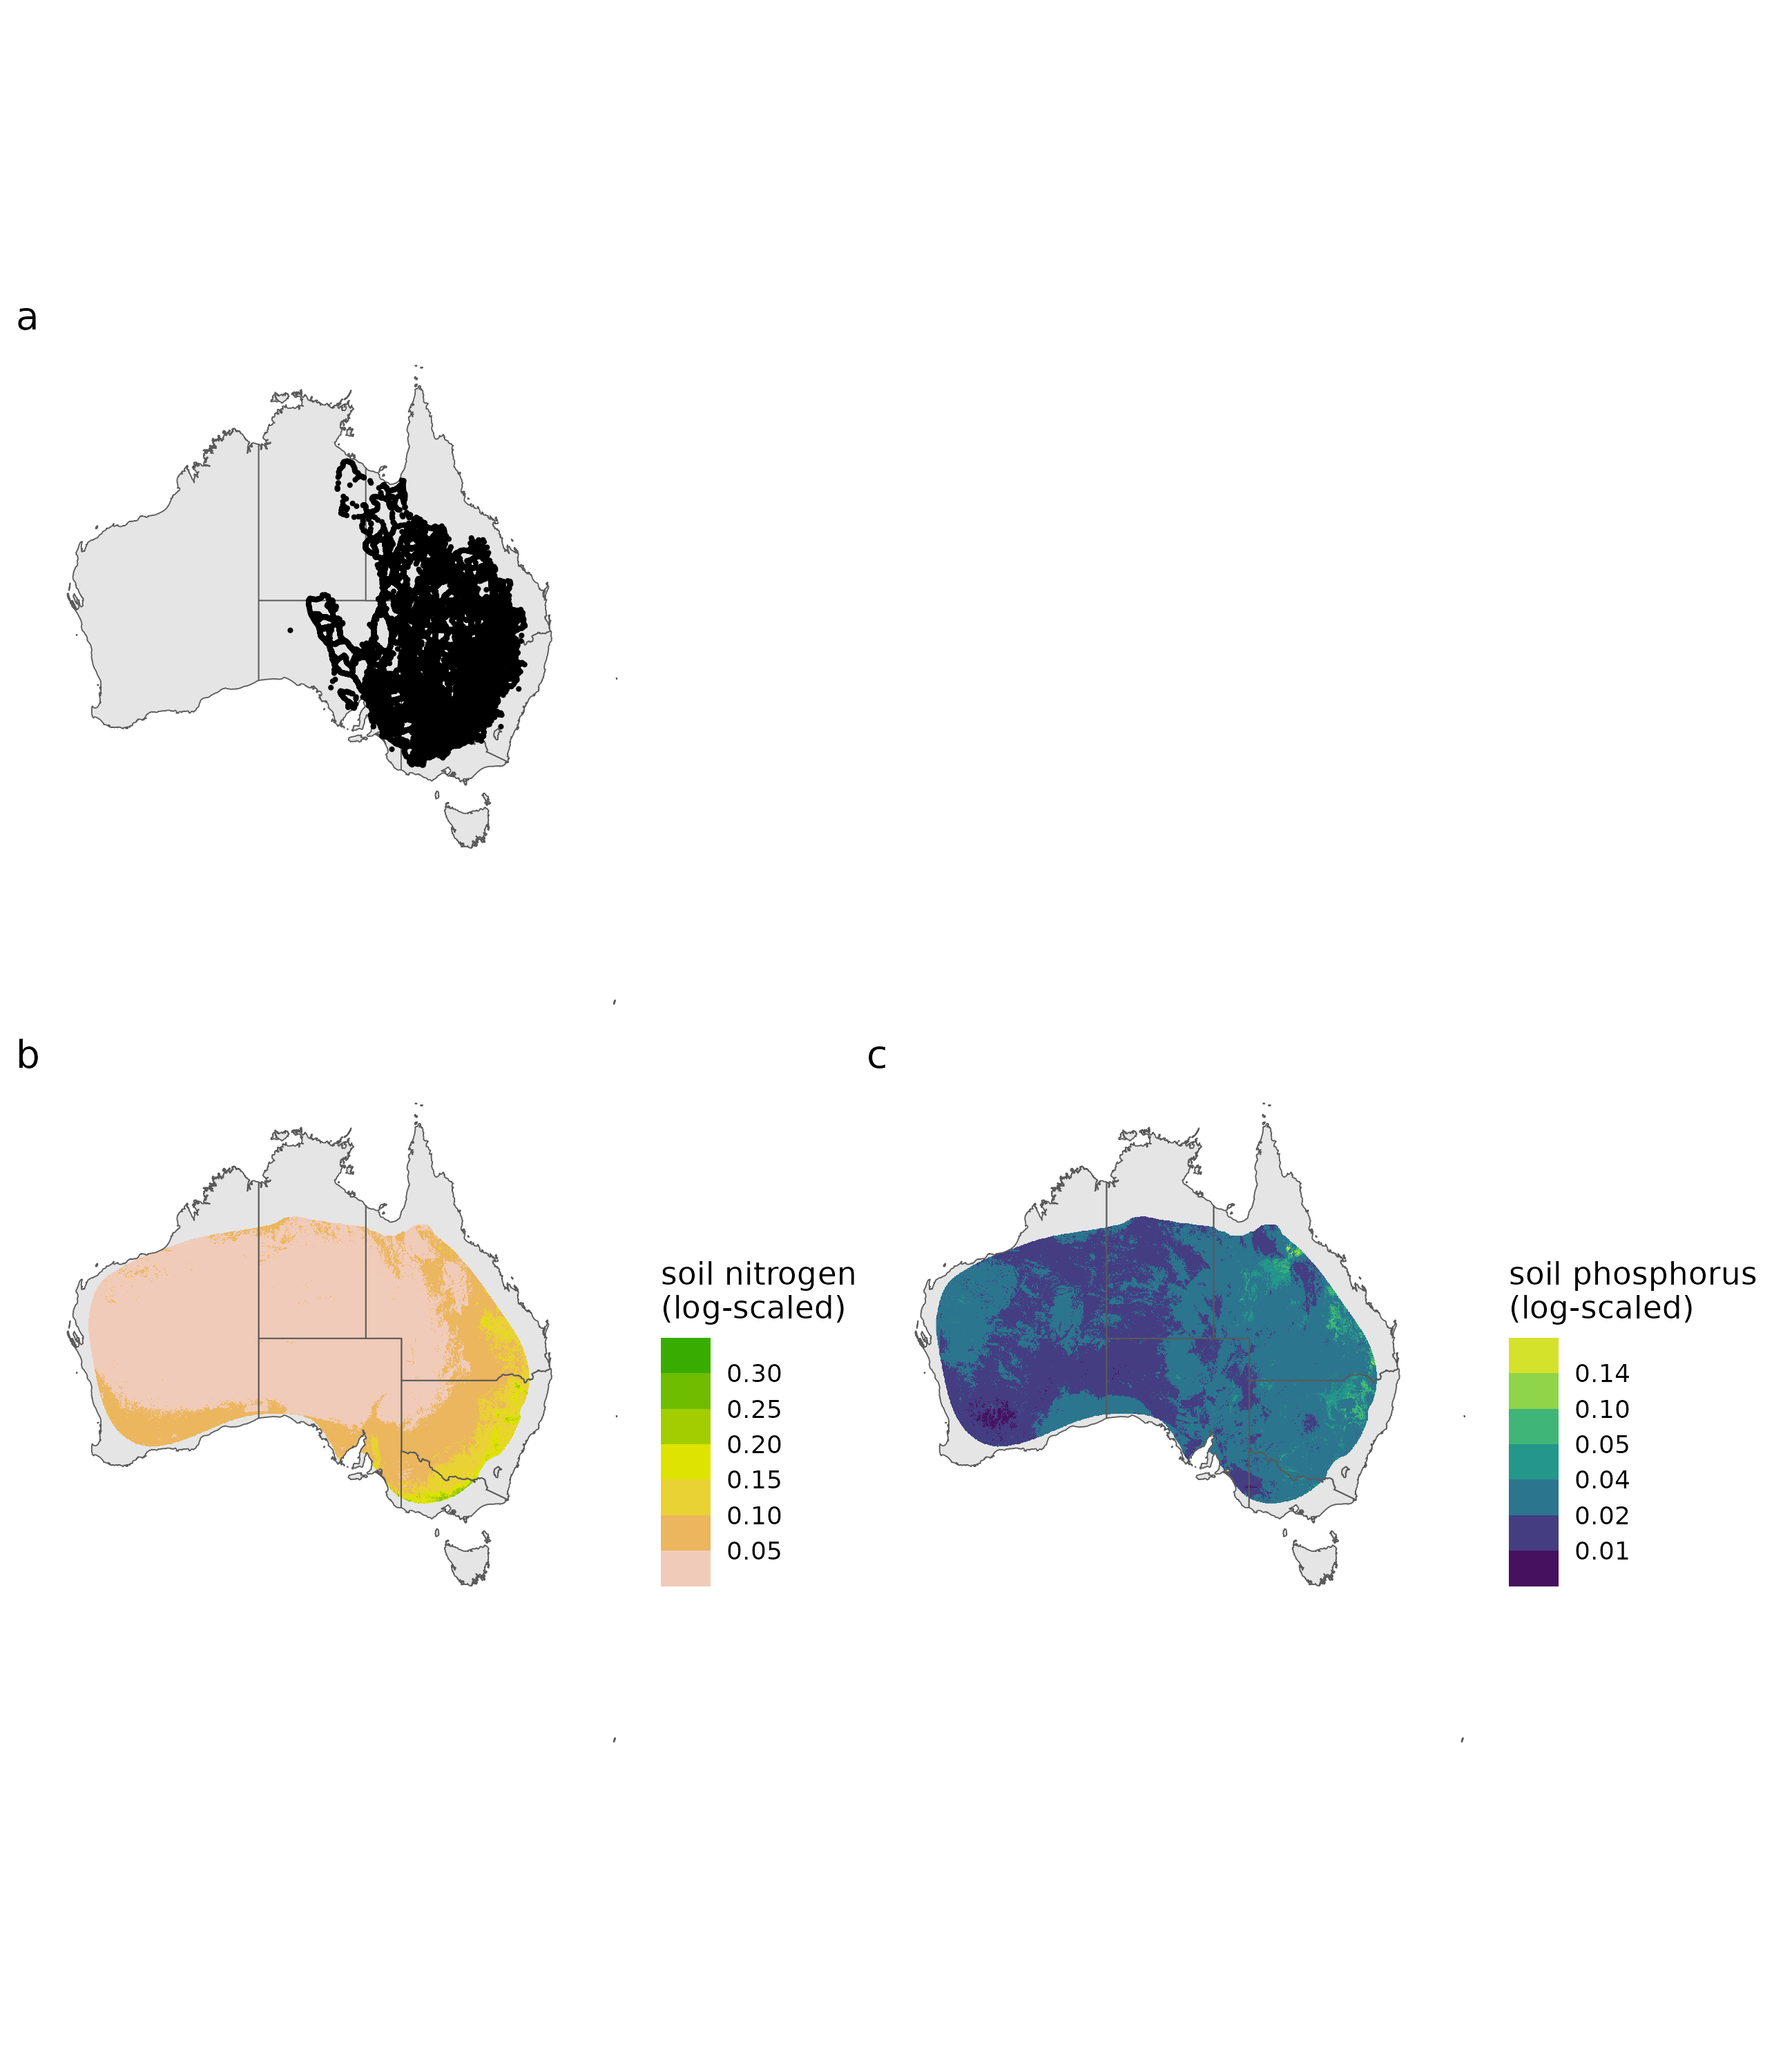
Figure 1: Locust survey data map and soil nutrients throughout the C. terminifera distribution. A: APLC survey dataset, B: mean proportion of nitrogen at 0-15 cm deep, C: mean proportion phosphorous at 0-15cm deep.

2.5 Statistics
All statistics were conducted with either a generalized additive (mixed) model or generlized linear (mixed) model approach when appropriate.This allowed us to test for non-linear and linear trends in the dataset and specify the hierarchical nature of the data. All statistics were conducted in R and python. All scripts and packages used can be seen within the project code repository: github repo.

2.5.1 Intake Targets (Question 1 and 2)
To determine intake targets, we constructed generalized additive model (GAM) (family: Multivariate Normal Distribution, Link: Identity) with the following variables when possible: diet pairing (factor), locust sex (factor), time period interval (integer), locust initial weight (numeric) following roughly the procedure found in Lawton et al. (2021). We selected the inclusion of locust weight as either a non-linear or linear effect via Akaike information criterion (AIC), AIC adjusted for small sample size (AICc), and Bayesian information criterion (BIC). If weight was not an important variable, it was removed entirely from the model.

2.5.2 Field population (Question 1)
We calculated intake targets as discussed above. To see the impact of confined diet treatments on both specific growth rate and development time, we constructed two linear models (family: gaussian, link: identity) with the following variables: treatment (factor), locust sex (factor), population (factor), and locust initial weight (numeric).

2.5.3 Field Cage Experiments (Question 2)
We assessed plant nutrients with a generalized additive mixed model (GAMM) (family: Multivariate Normal Distribution, link: identity) and included the following variables: plant carbohydrate (numeric, dependent), plant protein (numeric, dependent), treatment (factor, independent), cage (factor, random effect), plot (factor, random effect), and plant species (random effect). Redressing intake targets were conducted as discussed above (section 2.5.1). To see the difference between physiological performance and fertilizer treatments, we constructed GAMMs (family: Scaled T distribution, link: identity) for final locust mass. The independent variables in all models were treatment (factor), sex (factor), a two-dimensional smoother of available protein and carbohydrate, and cage number as a random effect. For both final adult proportion and survival proportion, we constructed a GAM (Family: gaussian, Link: identity) and included the following variables: treatment (factor) and a two-dimensional smoother of available protein and carbohydrate.

2.5.4 Historical outbreaks and soil nutrient grid modeling (Question 3)
To relate nymph survey grids to soil nitrogen and phosphorus, we constructed two GAMMs (family: tweedie, link: log) predicting the number of outbreaks (APLC Survey Category 4) and nil observations (category 0). Since soil nitrogen and mean annual precipitation are highly correlated with both variables decreasing going into the arid interior of Australia, we are unable to add precipitation directly to the model as it would bias the results. Instead, we built a comparison model with mean annual precipitation between 2000 and 2017 switched for soil nitrogen. To do this, we calculated the average precipitation between 2000 and 2017 for all survey grids using the European Centre for Medium-Range Weather Forecasts’ ERA5 reanalysis dataset (Muñoz-Sabater et al. 2021). This allowed us to visually compare the effect differences of soil nitrogen and mean annual precipitation on locust outbreaks. In other words, if soil nitrogen and mean annual precipitation were so tightly correlated that the effects are indistinguishable, the modeled results should look very similar. The soil models had the following independent variables: soil nitrogen, phosphorus, latitude / longitude, bioregion, and the number of observations within each grid. For the precipitation model, all variables were the same except mean annual precipitation replaced soil nitrogen and phosphorus. The inclusion of bioregions as a random effect allowed us to account for variation due to vegetation community and soil characteristics (Lawton et al. 2022). The inclusion of latitude and longitude allowed us to account for spatial autocorrelation (Clayton et al. 1993). Lastly, the inclusion of the total number of observations allowed us to account for sampling intensity biases.

3. RESULTS

3.1 Field population (Question 1)

3.1.1 Choice experiment (nutritional target)
Chortoicetes terminifera individuals from the two outbreaking populations regulated to a specific ratio of 1 protein : 2 carbohydrate (Figure 2 A,Table 2). Model selection can be seen in Supplementary Table 3. Consumption in the two diet pairings did not differ, indicating that instead of consuming between the diets randomly (which would be expected if nutrients had no impact on diet consumption) locusts were actively balancing their protein and carbohydrate consumption (Supplementary Figure 3 A, Table 2). While the protein : carbohydrate ratio did not change, females consumed more food than males, likely due to being bigger overall (Supplementary Figure 3 B, Table 2).
macronutrient | variable | estimate | SE | p-value
carbohydrate | Intercept | 0.026 | 0.002 | 0.000
 | Mendooran | -0.001 | 0.002 | 0.483
 | diet pair B | 0.001 | 0.002 | 0.573
 | male | -0.011 | 0.002 | 0.000
protein | Intercept | 0.014 | 0.001 | 0.000
 | Mendooran | -0.002 | 0.002 | 0.122
 | diet pair B | 0.002 | 0.002 | 0.293
 | male | -0.006 | 0.002 | 0.000
Table 2: Generalized additive model results for macronutrient consumption (carbohydrate and protein) of two outbreaking populations of C. terminifera in Mendooran and Guntawang. Models were selected via AIC, AICc and BIC which can be seen in Supplementary Table 3. Diet pair A and B had the following protein to carbohydrate ratios: 7p:35c & 28p:14c and 7p:35c & 35p:7c respectively. Family: multivariate gaussian distribution, link: identity, SE: standard error.

3.1.2 No choice experiment (performance curves)
Chortoicetes terminifera had higher specific mass growth rates and faster development times on the 1 protein : 2 carbohydrate (14 protein : 28 carbohydrate) diet as compared to the other diets (Figure 2 B & C, Table 3, Supplementary Table 4). Development time and specific growth rate did not differ between male and female locusts (Supplementary Figure 3 C & D, Table 3).
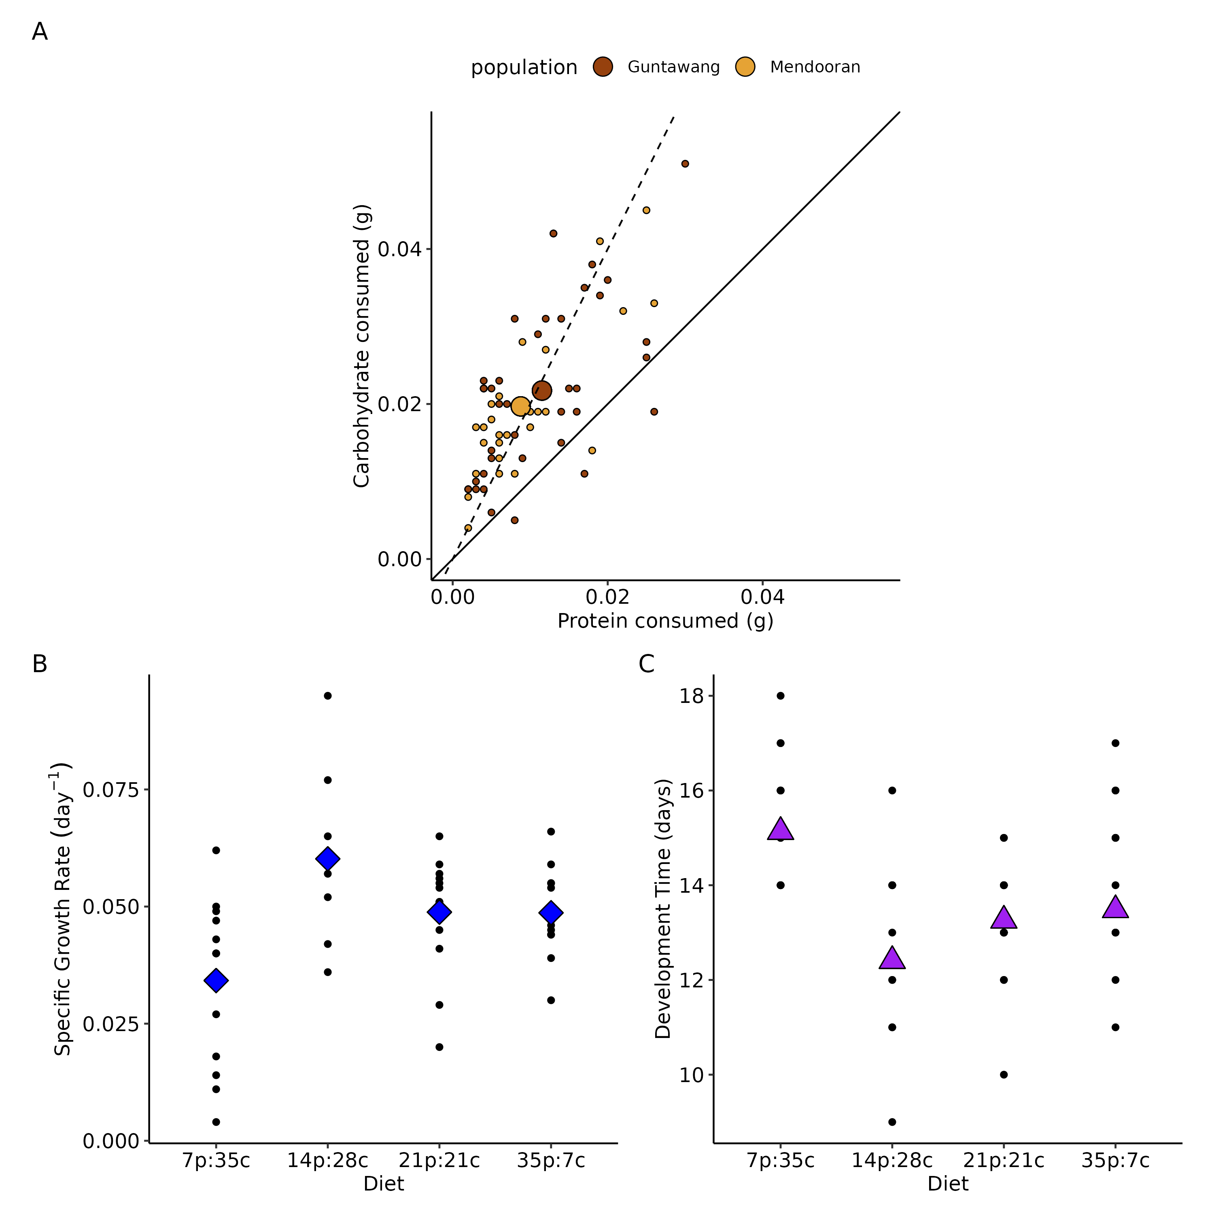
Figure 2: The nutritional preference (A) and physiological performance (B & C) of C. terminifera individuals that were collected from two marching bands of 5th instars. Raw data is shown as black dots with modeled estimated margial means as large diamonds or triangles.

 | Specific Growth Rate |  |  | Development Time
variable | estimate | SE | p-value | estimate | SE | p-value
Intercept | 0.061 | 0.004 | 0.000 | 15.780 | 1.555 | 0.000
21p:21c | -0.011 | 0.005 | 0.040 | 0.917 | 0.624 | 0.149
35p:7c | -0.010 | 0.006 | 0.091 | 1.709 | 0.665 | 0.013
7p:35c | -0.026 | 0.005 | 0.000 | 2.716 | 0.603 | 0.000
male | -0.003 | 0.004 | 0.398 | -1.615 | 0.829 | 0.057
initial weight (g) |  |  |  | -21.048 | 10.407 | 0.049
Table 3: Chortoicetes terminifera physiological performance (specific growth rate and development time) when constrained to specific diets with varying protein and carbohydrate content. SE: standard error. Posthoc comparisons for both physiological performance metrics can be seen in Supplementary Table 4.

3.2 Field Cage (Question 2)
For the first 11 days of the 14 day field cage experiment, plant protein and carbohydrate contents remained consistently protein-biased for all treatments (Figure 3 A-C, Table 4), and only showed differences in protein content by the last sample period on December 1, which was after the end of the locust cage experiment. Accordingly, there was no effect of fertilizer on locust survival and adult proportion (Figure 3 D-F, Table 5). Locusts that were retrieved from field cages after nine days and were given a choice to regulate protein and carbohydrate intake showed a pattern consistent with rebalancing a shortage of carbohydrates (Figure 4, Table 6, Supplementary Figure 4). Irrespective of fertilizer treatment group, locusts initially selected very carbohydrate biased diets, but gradually, after 9 days, their trajectory returned close to the predicted intake target of 1p : 2c (Figure 4, Supplementary Figure 4).
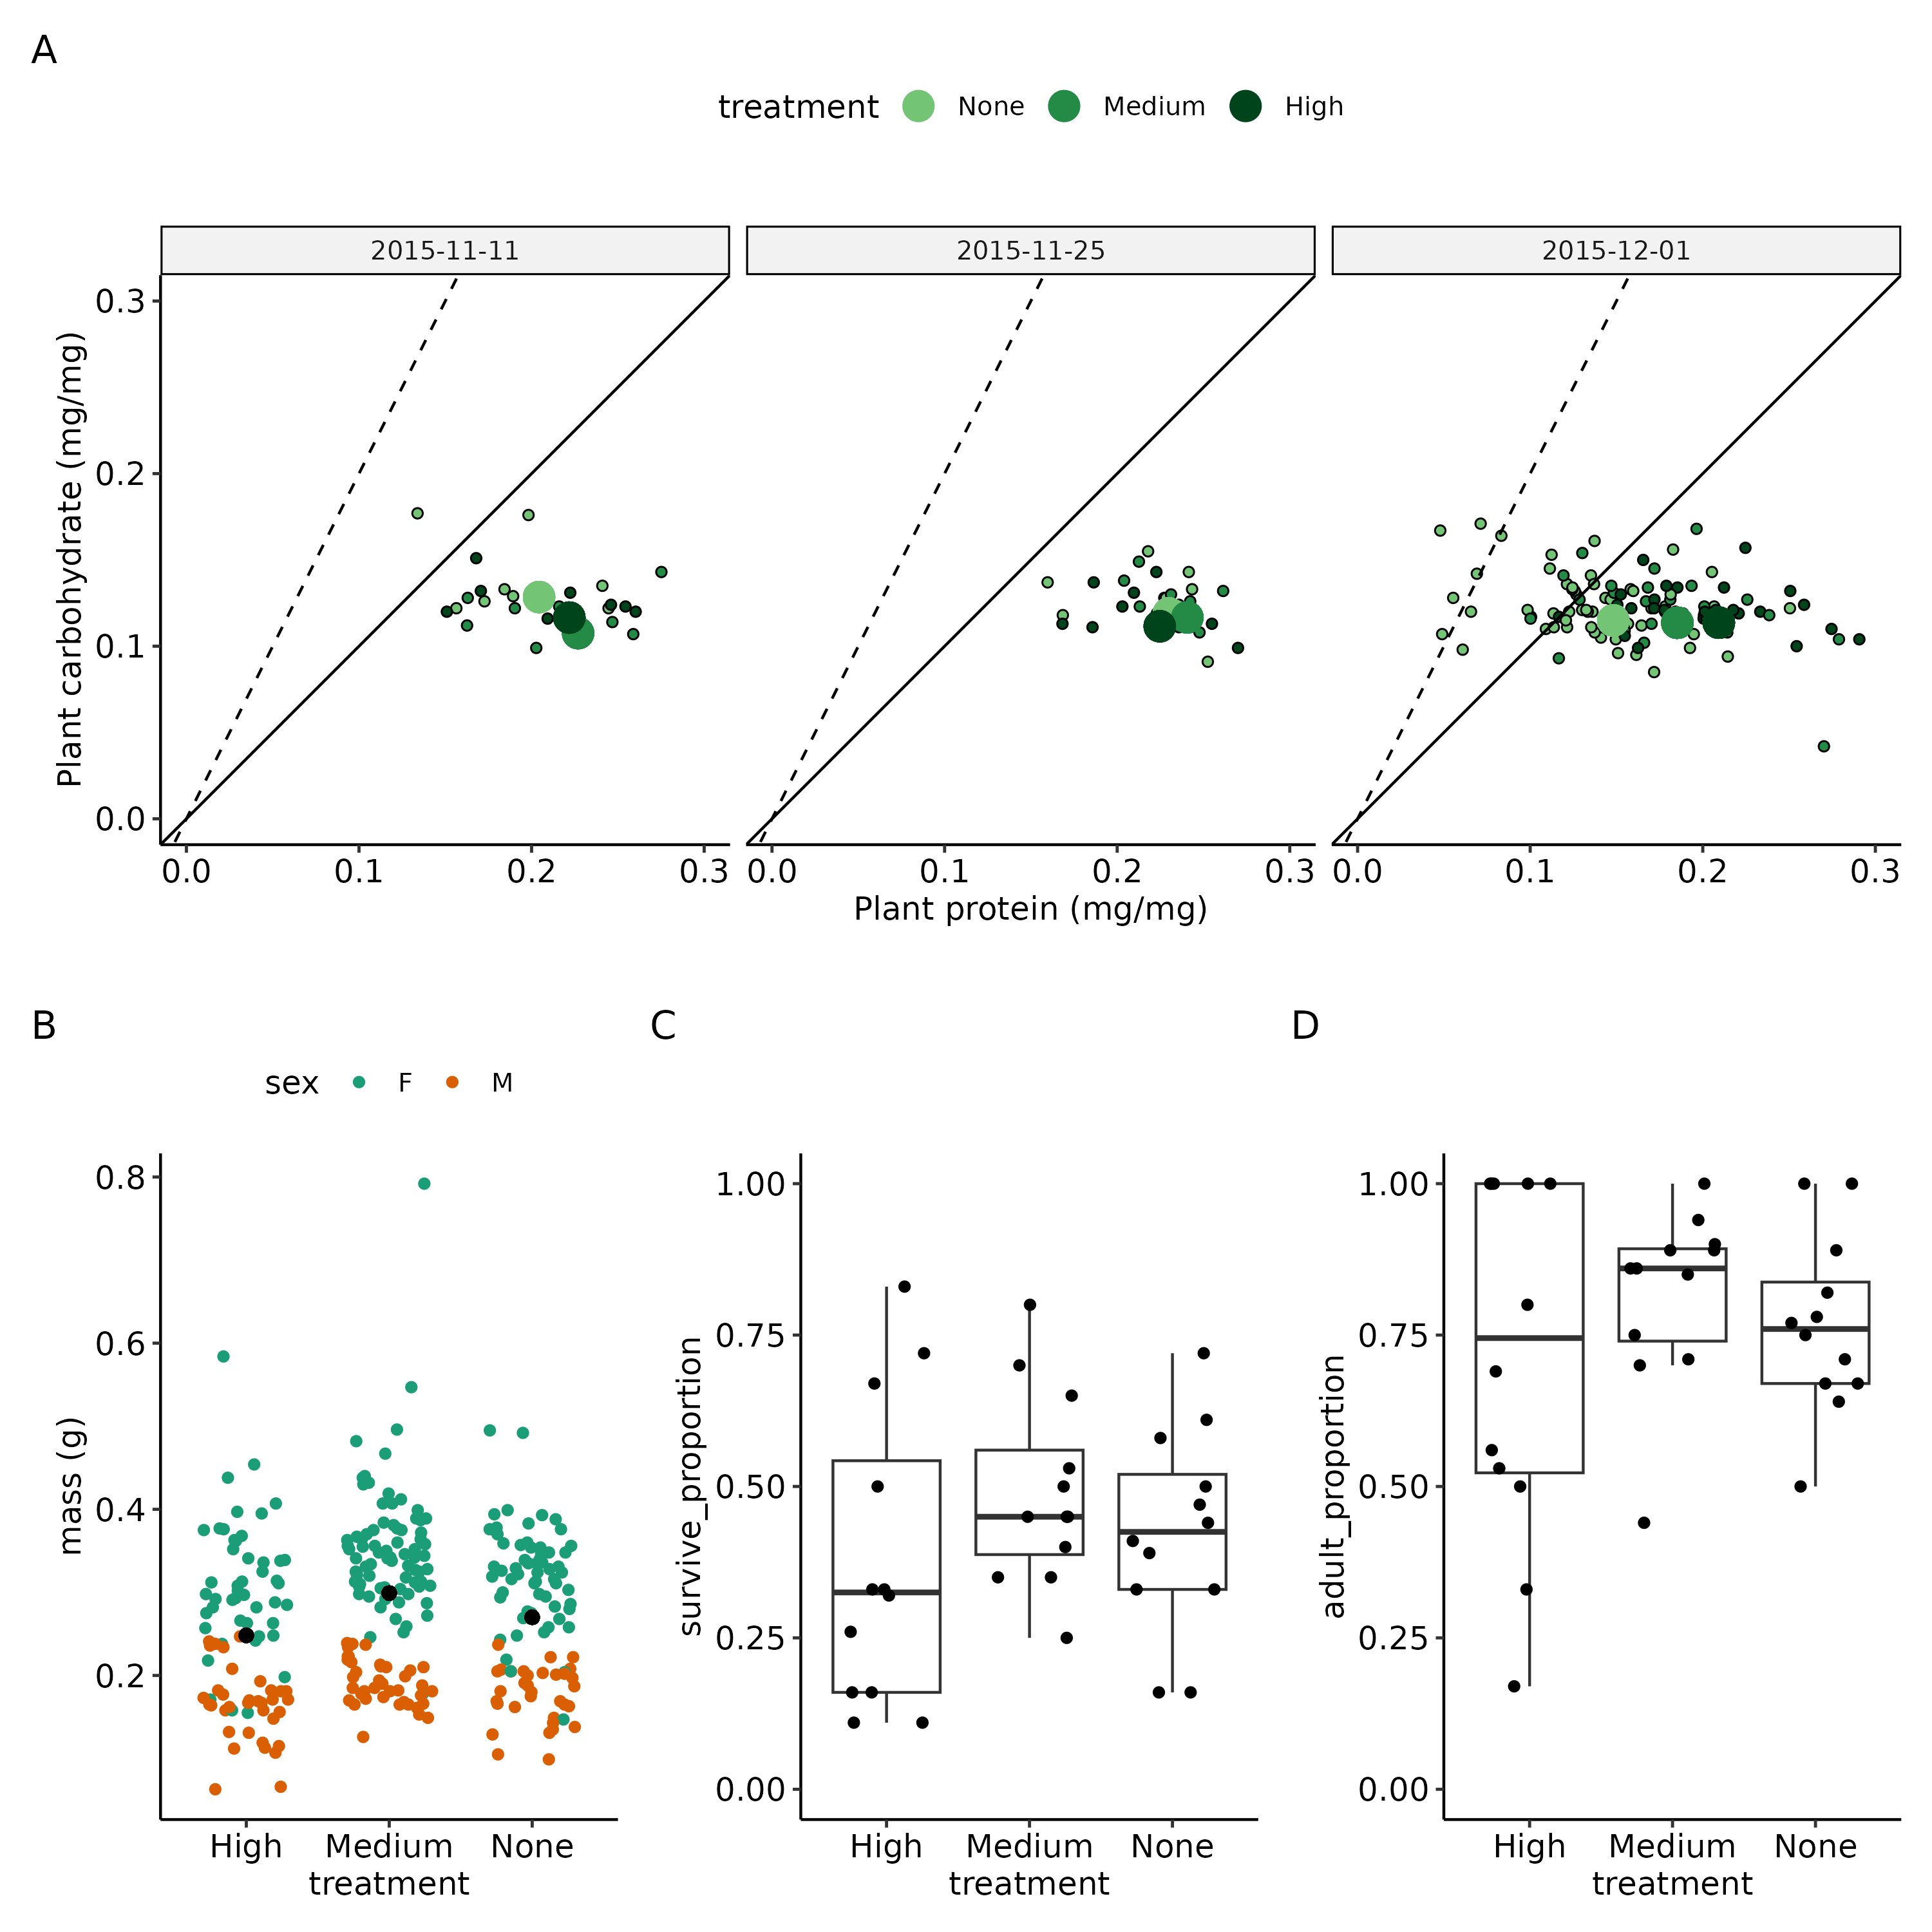
Figure 3: Nitrogen addition field cage experiments with plant nutrient change through time (A) and grasshopper performance metrics (B-C) are shown. Dashed line represents a 1p : 2c ratio, the solid line represents a 1p : 1c ratio. Black dots in B represent overall means whereas boxplots represent the lower, median, and upper quartlies.

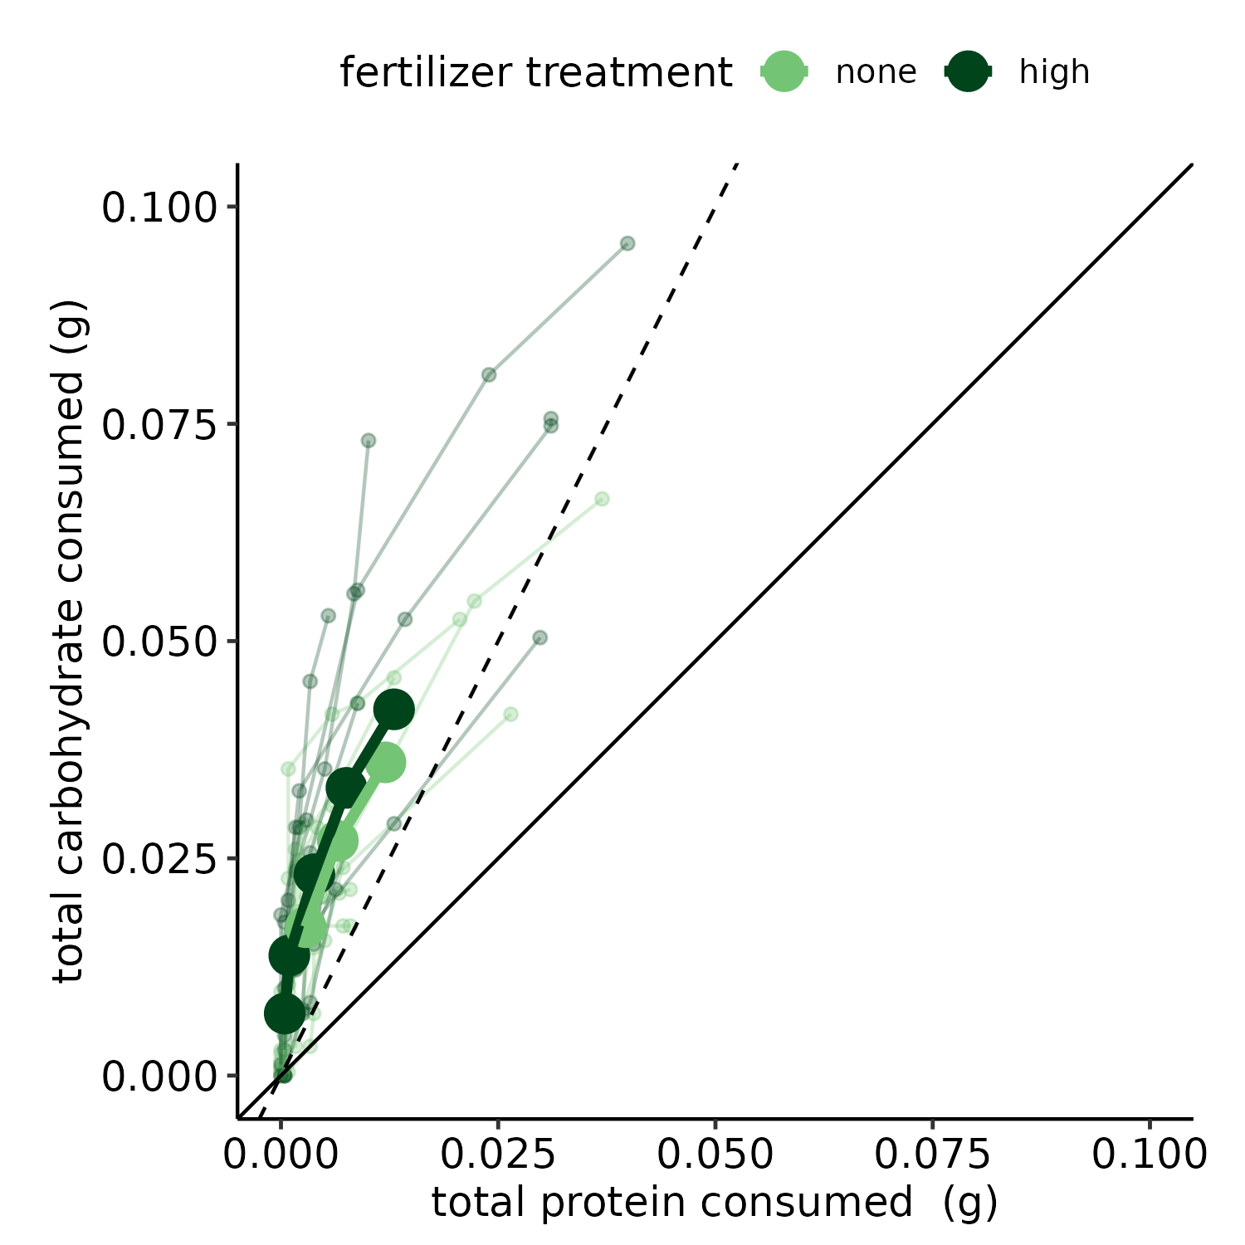
Figure 4: Nutrient imbalance redressing with artificial diet mixing of C. terminifera individuals taken from fertilized treatment cages. Colors represent fertilizer treatment. Smaller lines represent raw individual locust intake targets; large lines and points represent estimated marginal means. Points along each line represent sampling times on days 1, 2, 4, 6, and 9. Individual time step targets can be seen in Supplementary Figure 4.

macronutrient | variable | estimate | SE | statistic | p-value
carbohydrate | Intercept | 0.127 | 0.007 |  | 0.000
 | Medium | -0.020 | 0.007 |  | 0.005
 | High | -0.011 | 0.007 |  | 0.121
 | 2015-11-25 | -0.009 | 0.007 |  | 0.181
 | 2015-12-01 | -0.012 | 0.006 |  | 0.033
 | Medium:2015-11-25 | 0.019 | 0.010 |  | 0.063
 | High:2015-11-25 | 0.004 | 0.010 |  | 0.656
 | Medium:2015-12-01 | 0.019 | 0.008 |  | 0.017
 | High:2015-12-01 | 0.010 | 0.008 |  | 0.222
 | s(species) |  |  | 67.305 | 0.000
 | s(plot) |  |  | 1.643 | 0.207
 | s(cage) |  |  | 3.442 | 0.130
protein | Intercept | 0.209 | 0.017 |  | 0.000
 | Medium | -0.001 | 0.014 |  | 0.928
 | High | -0.034 | 0.014 |  | 0.014
 | 2015-11-25 | 0.026 | 0.010 |  | 0.014
 | 2015-12-01 | -0.049 | 0.009 |  | 0.000
 | Medium:2015-11-25 | -0.012 | 0.015 |  | 0.422
 | High:2015-11-25 | -0.023 | 0.015 |  | 0.123
 | Medium:2015-12-01 | 0.008 | 0.013 |  | 0.516
 | High:2015-12-01 | 0.056 | 0.013 |  | 0.000
 | s(species) |  |  | 307.929 | 0.000
 | s(plot) |  |  | 214.489 | 0.000
 | s(cage) |  |  | 89.944 | 0.000
Table 4: Generalized additive model results for plant macronutrient (carbohydrate and protein) differences between fertilization treatment. Family: multivariate gaussian distribution, link: identity, SE: standard error, s() denotes a smoothing parameter.

variable | estimate | SE | statistic | p-value
Intercept | 0.326 | 0.007 |  | 0.000
male | -0.148 | 0.006 |  | 0.000
medium | 0.015 | 0.010 |  | 0.117
high | -0.011 | 0.010 |  | 0.273
s(carb mg/mg, protein mg/mg) |  |  | 0.002 | 0.416
s(cage number) |  |  | 42.160 | 0.000
Table 5: Generalized additive model results for differences between final locust mass after the nitrogen fertilization experiment finished. Family: scaled T, link: identity, SE: standard error, and s() denotes a smoothing parameter.

macronutrient | variable | estimate | SE | statistic | p-value
carbohydrate | Intercept | 0.013 | 0.004 |  | 0.001
 | male | -0.011 | 0.004 |  | 0.009
 | day 2 | 0.007 | 0.003 |  | 0.008
 | day 3-4 | 0.016 | 0.003 |  | 0.000
 | day 5-6 | 0.026 | 0.003 |  | 0.000
 | day 7-9 | 0.035 | 0.003 |  | 0.000
 | none | -0.006 | 0.004 |  | 0.136
 | s(id) |  |  | 484.706 | 0.000
protein | Intercept | 0.002 | 0.001 |  | 0.119
 | male | -0.004 | 0.001 |  | 0.009
 | day 2 | 0.001 | 0.001 |  | 0.724
 | day 3-4 | 0.003 | 0.001 |  | 0.023
 | day 5-6 | 0.007 | 0.001 |  | 0.000
 | day 7-9 | 0.013 | 0.001 |  | 0.000
 | none | -0.001 | 0.001 |  | 0.475
 | s(id) |  |  | 110.728 | 0.381
Table 6: Generalized additive model results for nutrient imbalance dressing of field cage C. terminifera in the control and high fertilization treatments. Model also included interactive terms; however, none were significant and left out. SE: standard error and s() denotes a smoothing parameter.

3.3 Locust outbreaks (Question 3)
Chortoicetes terminifera outbreaks were negatively associated with soil nitrogen, which supports the hypothesis that nitrogen (in excess) acts as a limiting factor for population upsurges (Table 7, Figure 5 A). C. terminiferas had a nonlinear relationship with soil phosphorus with outbreaks occurring more often in areas with approximately 4% soil phosphorus and were strongly negatively associated with increasing phosphorus afterwards (Figure 5 B). For both nutrients, the absence models had a very weak relationship with soil nutrient in comparison to the outbreak models, demonstrating little model bias due to APLC survey protocol. There were significant nonlinear relationships between coordinates and the total number of observations in all models (Supplementary Figure 6; Supplementary Figure 7). The relationship between locust outbreaks and mean annual precipitation was very different from the relationship with soil nitrogen ( Figure 5, Supplementary Figure 8). Soil nitrogen and phosphorus show weak positive correlations with woody vegetation cover, while mean annual precipitation exhibits high variation in its relationship with soil nitrogen and weak correlation with soil phosphorus (Supplementary Figure 5). Thus, the relationship between soil nitrogen and locust outbreaks cannot be fully explained by differences in woody vegetation.
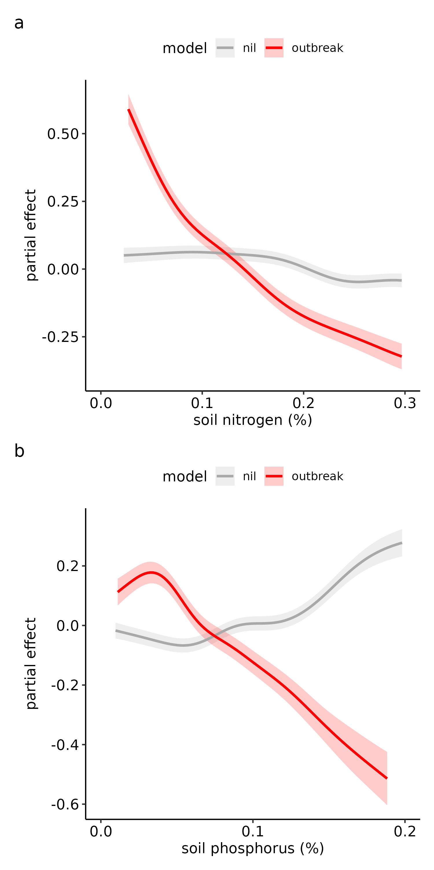
Figure 5: Relationship between outbreaks and nil observations for both soil nitrogen (A) and phosphorus (B). Partial effect is the modeled predictions after accounting for bioregion and spatial autocorrelation.

 | outbreak model |  |  | nil model
variable | EDF | statistic | p-value | EDF | statistic | p-value
s(nitrogen) | 6.273 | 25.620 | 0.000 | 6.426 | 35.340 | 0.000
s(phosphorus) | 5.372 | 15.521 | 0.000 | 6.407 | 28.867 | 0.000
s(number of observations) | 22.547 | 630.896 | 0.000 | 22.408 | 3,199.357 | 0.000
te(longitude,latitude) | 56.140 | 1.148 | 0.012 | 131.476 | 3.302 | 0.000
s(ecoregion) | 6.498 | 4.802 | 0.000 | 2.726 | 0.361 | 0.035
Table 7: Historical locust presence data modeling with soil nitrogen for outbreak, low presence, and no observation records with r-square and deviance explain reported. Family: tweedie, link: log, edf = estimated degrees freedom.

4. DISCUSSION
We show that herbivore diet preferences remain consistent between spatial levels, from individual foraging behavior and physiology to large scale population dynamics, with locust populations negatively related to environmental nitrogen. Thus by going across scales, this study shows a consistent pattern of excess nitrogen limiting a pest herbivore and introduces a more nuanced view of phosphorus limitation on herbivore populations. Instead of the broad generalization that animals are always negatively or positively associated with certain nutrients, specific life history traits, such as energetically-costly migration, as well as organism-environment interactions should be considered. While this study advances our understanding of nutrient limitation across scales, future work should explicitly assess phosphorus nutrient imbalances at finer scales to clarify their influence on broader patterns of herbivore population dynamics. Investigating multi-scale nutrient interactions, including a wider array of nutrients such as potassium and sodium, could also provide a more comprehensive framework for modeling herbivore responses to environmental heterogeneity. For forecasting pest populations dynamics, describing the nutritional quality of landscapes can inform seasonal scouting surveys. We hope that this study spurs future interest in multi-scale experiments and modeling of nutrient availability with animal population dynamics.

4.1 Field populations
Field populations of final instar C. terminifera behaviorally regulated to a 1 protein (p) : 2 carbohydrate (c) nutrient ratio, which supported the fastest nymphal growth and the lowest development time to adulthood (Figure 2 B & C), consistent with previous studies (Clissold et al. 2014, Lawton et al. 2021). Locusts are highly mobile (C. terminifera can fly up to 500 km in a single night, (Deveson and Walker 2005)) and the demand for energy via carbohydrates and lipids likely increases relative to protein demand during the later life stages of these animals.
Plant nutrient content in the nitrogen fertilization treatments was not significantly different until the last sample period, which likely explains the small effect on locust growth (Figure 3 A-C). Over the experimental period, protein content decreased in unfertilized treatments while both plant protein and carbohydrate remained constant in the fertilized treatments. If we prolonged the experiment, there might have been a noticeable difference in locust survivorship, weight gain, and adult proportion given the shift in nutrients among treatments (Figure 3 D-F).
Importantly, all field cage plants were protein biased (roughly 1p : 1c to 2p : 1c ) as compared to the desired locust intake target of 1p : 2c. When locusts were subsampled from the field cages mid-experiment and given the opportunity to select carbohydrate or protein diets, they selected extremely carbohydrate-biased diets for more than a week. This behavior indicated that locusts in the small field cages were highly carbohydrate-limited, driving them to overeat carbohydrates to redress the imbalance. Interestingly, multiple studies have shown that the Australian nutritional landscape is often too protein-biased relative to what the C. terminifera prefers (Lawton et al. 2020, 2021). Regardless, populations are still persistent and outbreaks can occur at lower frequencies in these areas (Key 1945, Deveson 2013). How this species can achieve the optimal balance of nutrients within an unfavorable nutritional environment merits further investigation, but may include post-ingestive regulation and/or large-range foraging. Migratory locusts (Locusta migratoria) can choose microclimates that favor higher efficiency of carbohydrate or protein absorption depending on their host plant and nutritional status (Clissold et al. 2013). For this study, we collected free-living locusts from the same region and a similar environment as where we built the field cages, yet those confined to field cages selected a 10x decrease in p:c (1p : 20c vs 1p : 2c). This result suggests that free-living locusts are able to persist in high protein regions by foraging over a larger range to seek out pockets of carbohydrate-rich plants and that the limited foraging range of the field cages precluded field-cage locusts from finding sufficient carbohydrates. Similarly, these results suggest that, while C. terminifera can persist in low numbers in nitrogen rich regions, those environments are unlikely to support extreme outbreaks due to a limitation of carbohydrate-rich resources.

4.2 Historical outbreak modeling
This is the first time to our knowledge that terrestrial animal population dynamics have been modeled with nutrients at the continental level, allowing nutrient limitation to be tested at a scale not previously investigated. Locust outbreaks are associated with less soil nitrogen (Figure 5 A), suggesting that nitrogen acts as a limiting factor not due to its deficit (White 1993) but its excess. Plants growing in high nitrogen environments tend to have high p:c ratios, which force locusts to either undereat carbohydrates (limiting their energy to support growth and migration) or overeat protein (which can be toxic) to acquire sufficient carbohydrates (Behmer 2009, Cease 2024). On the other end of the performance curve, C. terminifera do have a lower p:c range that limits performance, as shown using artificial diets (Figure 2 B-C). We also show that outbreaks are correlated with a low level of soil phosphorus, however, outbreaks peak at approximately 4%, suggesting that while locusts generally do well in low phosphorus environments, phosphorus deficit can be limiting for locusts in extremely phosphorus poor soils (Figure 5 B). Because Australian soils are characteristically phosphorus poor (Donald 1964), Australian animals like this locust are adapted to phosphorus poor environments and potentially having too much phosphorus is deleterious (Morton et al. 2011). Locust populations may be more tightly correlated with soil nitrogen than phosphorus because terrestrial herbivores require 5-50 times more nitrogen than phosphorus (Elser et al. 2000), meaning they can more readily balance phosphorus by eating a few foods rich or poor in phosphorus but cannot as quickly regulate protein and carbohydrate energy because they make up the bulk of their required nutrients. Indeed, laboratory studies have revealed that short-term limitations in dietary phosphorus have no apparent impact on grasshopper growth (Cease et al. 2016), suggesting that these mobile herbivores could seek out phosphorus-rich diets intermittently to overcome potential phosphorus limitation in field environments. However, in this study, we only tested this relationship with phosphorus at the continental level; further field and laboratory experiments are needed to explore this non-linear relationship between locust outbreaks and soil phosphorus. While we only looked at nitrogen and phosphorus, it is also important to note that animals require a suite of nutrients. Other nutrients such as potassium and sodium (Joern et al. 2012) warrant further investigation. Comparing locust outbreaks between continents would further show the relationship between nutrient availability and animal population dynamics. One excellent dataset for this would be SoilGrids (https://www.isric.org/explore/soilgrids) which provides soil nitrogen estimates globally at a 250-meter resolution.
Lastly, our results suggest that forecasting efforts for locusts should consider the inclusion of a nutritional landscape quality metric like soil nitrogen. Current forecasting models use climatic data (e.g. rainfall and soil moisture) or vegetation growth data (e.g. normalized difference vegetation index, NDVI) as the major predictors of outbreaks (Cressman 2013). While these climatic variables are clearly important, adding metrics to quantify the nutritional landscape can help increase forecasting model accuracy in environments with highly variable climates.

4.3 Locusts are more likely to be limited by high nitrogen environments than other grasshoppers
A five-decade review of grasshopper responses to plant nitrogen content showed that grasshoppers not classified as locusts have a variation of negative, neutral, and positive responses to increasing plant nitrogen (Cease 2024). Looking just at field surveys, there are more reports of a negative correlation between plant nitrogen and non-locust grasshopper abundance (17 reports) relative to neutral (6 reports) or positive (9 reports). This pattern corroborates long-term studies showing that dilution of plant nitrogen is correlated with declines of North American grasshopper populations (Welti et al. 2020a). Of the studies that report positive correlations between individual grasshopper species abundance and plant nitrogen, most are from graminivorous (grass-feeding) species (11 reports), with 7 reports from mixed (grasses and forbs) or forb feeders (Cease 2024). This pattern supports the hypothesis that grass-feeders are more likely to be nitrogen-limited because grasses tend to have lower p:c ratios than forbs; although this trend was not significant and grass-feeders also regularly showed negative responses to high plant nitrogen. In contrast, there was a consistent negative effect of high plant nitrogen on locust species, regardless of whether they were graminivorous or mixed feeders. Because mass specific protein consumption is highly correlated with growth rate in both lab and field populations, but carbohydrate consumption is highly influenced by the environment (Talal et al. 2024b), it is most likely that locusts have similar protein requirements as other non-locust grasshopper species, but have much higher carbohydrate demands, potentially to support migration (Raubenheimer and Simpson 1997, Talal et al. 2021, 2024b). Locusts are able to meet this increased demand for carbohydrate, while keeping protein consumption constant, by eating larger amounts of low p:c plants found in low nitrogen environments. In summary, these studies suggest that nymphal outbreaks of all locust species may be negatively correlated with soil nitrogen across continental scales, but that the correlation between plant nitrogen and non-locust grasshoppers may not be significant or consistent through space and time.

4.4 Comparing the relationship between plant macronutrients and herbivore abundance in other taxa
The effect of plant protein and carbohydrate on herbivore populations is predicted to depend on the herbivore’s p:c intake target (IT) relative to its nutritional landscape (Le Gall et al., 2020). If there are sufficient plants on either side of the IT, herbivores can select from between them to achieve their IT. This complementary feeding has been recorded for field populations of blue sheep (Psuedois nayaur) in the Himalayan Mountains (Aryal et al. 2015), Black Howler Monkeys (Alouatta pigra) in Yucatán (Bridgeman 2012), and other primates (Raubenheimer and Rothman 2013). There would be a predicted impact on populations if the nutritional landscape were to become more constricted or not overlap with the IT. For example, lab colonies of tobacco hornworms (Manduca sexta larvae) have an IT around 1:1 or sometimes slightly carbohydrate-biased (Wilson et al. 2019a) and their host plants tend to be carbohydrate-biased relative to their IT (Wilson et al. 2019b). However, this does not seem to translate to population level effects, potentially due to secondary metabolites affecting growth more strongly than macronutrient balance and/or larvae may be able to compensate by overeating carbohydrates to acquire sufficient protein (Wilson et al. 2019a). Overeating carbohydrates is not as detrimental as overeating protein, at least in the short term, and animals tend to be willing to overeat carbohydrates to a greater extent than protein (Cheng et al. 2008, Simpson and Raubenheimer 2012). Therefore, herbivores facing a nutritional landscape with a p:c generally lower than their IT (i.e., carbohydrate excess) may not be as negatively impacted as herbivores facing one higher than their IT (i.e., protein excess). However, there are several examples of higher localized densities of herbivores in response to higher plant nitrogen and protein contents with thrips (Brown et al. 2002) and spruce budworm (Choristoneura) (De Grandpré et al. 2022) being two examples. These examples suggest that low p:c diets limit population growth of some herbivores, but more studies are needed to determine if this relationship is only localized or if it scales up. It may be that herbivore populations with lower numbers are not limited by a nutritional landscape at a large scale because they can differentially disperse locally among optimal patches, whereas herbivore populations with extreme numbers (i.e., irruptions) may be more limited by nutritionally unfavorable environments across scales.
Herbivore responses to nutrient variation often exhibit species-specific patterns, even among closely related species within the same feeding guild. For instance, generalist grasshoppers (Melanoplus spp.) coexist by occupying distinct nutritional niches, varying their protein-to-carbohydrate intake ratios despite consuming overlapping host plants (Behmer and Joern 2008). Similarly, Euchorthippus cheui and E. unicolor display opposing preferences for nitrogen-enriched versus nitrogen-depleted host plants, leading to divergent population responses to fertilization and grazing pressure (Zhu et al. 2020a, 2023). These examples highlight how phenological or physiological differences shape responses to shared nutritional landscapes. Building on these findings, we hypothesize that related locust species, including Chortoicetes terminifera, may also exhibit distinct nutrient preferences, potentially driven by local adaptations to environmental conditions. Investigating these differences could provide insights into how nutrient availability influences herbivore population dynamics across ecological scales.
There is evidence for phosphorus limitation in some species, but limited research showing a detrimental effect of excess phosphorus (Cease et al. 2016). In aquatic insects such as Daphnia species, there is a strong positive association with phosphorus available and population dynamics Andersen et al. (2004). However this trend is not seen in field cricket populations (Gryllus veletis) (Harrison et al. 2014) and other terrestrial insects. Loaiza et al. (2011) found no effect of phosphorus fertilization (but a positive effect of N fertilization) on Kansas tallgrass prairie grasshopper population distributions, whereas Joern et al. (2012) found consistent positive correlations between plant phosphorus and Nebraskan grassland grasshopper populations.
Making predictions about a population’s nutritional demands can aid in making predictions about the relationship between nutritional landscapes and population dynamics. Across taxa, including fish, chickens, rats, cats, caribou, pigs, and dairy cattle, mass specific protein consumption is highly correlated with growth rate and decreases with age and body size (Talal et al. 2024b). In contrast, energy demand (carbohydrates and lipids) does not show a clear relationship with growth rate and instead is more affected by environment and activity (Talal et al. 2024b). Therefore, an animal’s IT is predicted to be affected by the contrasting effects of growth (increases dietary p:c) and activity or stress (increases carbohydrate demand and therefore decreases dietary p:c), although other physiological and environmental factors affect p:c demand as well (see Table 1 in Cease (2024)). For example, monarch butterflies have been gradually increasing their already-high daily energy expenditure during migration due to warmer temperatures caused by climate change (Parlin et al. 2023). Young and fast growing herbivores with low activity levels would be predicted to have a high p:c IT, whereas older juveniles and adults (slower mass specific growth) with high activity levels would be predicted to have a low p:c IT. Comparative studies with herbivores grouped functionally, such as other highly migratory animals (e.g. across insects, birds, mammals, and fish), or by growth rate or developmental stage, would likely provide interesting parallels that would assist in disentangling the complexities of plant macronutrient-herbivore relationships.

4.5 Synthesis and Application
Acquiring the right amount of nutrients is a critical component for animal growth, reproduction, and population dynamics (Hansson 1979, Keith 1983, Doonan and Slade 1995). However, in contrast to the conventional hypotheses that predict a broad positive linear relationship between herbivorous populations and nitrogen and phosphorus (White 1978, Mattson 1980, White 1993, Huberty and Denno 2006), the story is nuanced and probably most often non-linear. For some species, especially those with high energy requirements, the relationship is the opposite (negatively associated with nitrogen) like many locust species and the effects can be seen at the continental scale. Land use and Land Cover Change (LULCC) impact on nutritional environments has important implications for animal population dynamics from conservation to pest management. While we did not make an explicit connection between LULCC and locust outbreaks in Australia, our results are consistent with previous research showing that LULCC that decreases soil quality and creates low nitrogen environments increases physiological performance and outbreaks of locusts (reviewed in Le Gall et al. (2019)). Most importantly, we show that this relationship is consistent between scales from the individual locust to continental wide outbreaks. As such, proper management of soil nutrients can help keep locust populations from reaching outbreak sizes and should be considered across scales, from individual locust behavior to continental-wide plagues.

5. REFERENCES
Andersen, T., Elser, J. J. and Hessen, D. O. 2004. Stoichiometry and population dynamics. - Ecology Letters 7: 884–900.
Aryal, A., Coogan, S. C. P., Ji, W., Rothman, J. M. and Raubenheimer, D. 2015. Foods, macronutrients and fibre in the diet of blue sheep ( Psuedois nayaur ) in the Annapurna Conservation Area of Nepal. - Ecology and Evolution 5: 4006–4017.
Batzli, G. O. 1986. Nutritional Ecology of the California Vole: Effects of Food Quality on Reproduction. - Ecology 67: 406–412.
Behmer, S. T. 2009. Insect Herbivore Nutrient Regulation. - Annual Review of Entomology 54: 165–187.
Behmer, S. T. and Joern, A. 2008. Coexisting generalist herbivores occupy unique nutritional feeding niches. - Proceedings of the National Academy of Sciences 105: 1977–1982.
Bernays, E. A., Bright, K. L., Gonzalez, N. and Angel, J. 1994. Dietary Mixing in a Generalist Herbivore: Tests of Two Hypotheses. - Ecology 75: 1997–2006.
Bridgeman, L. L. 2012. The feeding ecology of yucatán ¡n black howler monkeys (alouatta pigra) in mangrove forest, tabasco, mexico.
Brosemann, J., Overson, R., Cease, A. J., Millerwise, S. and Le Gall, M. 2023. Nutrient supply and accessibility in plants: Effect of protein and carbohydrates on Australian plague locust (Chortoicetes terminifera) preference and performance. - Frontiers in Insect Science 3: 1110518.
Brown, A. S. S., Simmonds, M. S. J. and Blaney, W. M. 2002. Relationship between nutritional composition of plant species and infestation levels of thrips. - Journal of Chemical Ecology 28: 2399–2409.
Cease, A. J. 2024. How Nutrients Mediate the Impacts of Global Change on Locust Outbreaks. - Annual Review of Entomology 69: 527–550.
Cease, A. J., Elser, J. J., Ford, C. F., Hao, S., Kang, L. and Harrison, J. F. 2012. Heavy Livestock Grazing Promotes Locust Outbreaks by Lowering Plant Nitrogen Content. - Science 335: 467–469.
Cease, A. J., Elser, J. J., Fenichel, E. P., Hadrich, J. C., Harrison, J. F. and Robinson, B. E. 2015. Living With Locusts: Connecting Soil Nitrogen, Locust Outbreaks, Livelihoods, and Livestock Markets. - BioScience 65: 551–558.
Cease, A. J., Fay, M., Elser, J. J. and Harrison, J. F. 2016. Dietary phosphate affects food selection, post-ingestive P fate, and performance of a polyphagous herbivore. - Journal of Experimental Biology: jeb.126847.
Cease, A. J., Trumper, E. V., Medina, H., Bazán, F. C., Frana, J., Harrison, J., Joaquin, N., Learned, J., Roca, M., Rojas, J. E., Talal, S. and Overson, R. P. 2023. Field bands of marching locust juveniles show carbohydrate, not protein, limitation. - Current Research in Insect Science 4: 100069.
Cheng, K., Simpson, S. J. and Raubenheimer, D. 2008. A Geometry of Regulatory Scaling. - The American Naturalist 172: 681–693.
Clark, D. 1974. The Influence of Rainfall on the Densities of Adult Chlortoicetes Terminifera (Walker) in Central Western New South Wales, 1965-73. - Australian Journal of Zoology 22: 365.
Clayton, D. G., Bernardinelli, L. and Montomoli, C. 1993. Spatial Correlation in Ecological Analysis. - International Journal of Epidemiology 22: 1193–1202.
Clissold, F. J., Coggan, N. and Simpson, S. J. 2013. Insect herbivores can choose microclimates to achieve nutritional homeostasis. - Journal of Experimental Biology: jeb.078782.
Clissold, F. J., Kertesz, H., Saul, A. M., Sheehan, J. L. and Simpson, S. J. 2014. Regulation of water and macronutrients by the Australian plague locust, Chortoicetes terminifera. - Journal of Insect Physiology 69: 35–40.
Cole, F. R. and Batzli, G. O. 1978. Influence of Supplemental Feeding on a Vole Population. - Journal of Mammalogy 59: 809–819.
Cressman, K. 2013. Role of remote sensing in desert locust early warning. - Journal of Applied Remote Sensing 7: 075098.
Cullen, D. A., Cease, A. J., Latchininsky, A. V., Ayali, A., Berry, K., Buhl, C., De Keyser, R., Foquet, B., Hadrich, J. C., Matheson, T., Ott, S. R., Poot-Pech, M. A., Robinson, B. E., Smith, J. M., Song, H., Sword, G. A., Vanden Broeck, J., Verdonck, R., Verlinden, H. and Rogers, S. M. 2017. From Molecules to Management: Mechanisms and Consequences of Locust Phase Polyphenism. - In: Advances in Insect Physiology. Elsevier, pp. 167–285.
Dadd, R. H. 1961. The nutritional requirements of locusts—IV. Requirements for vitamins of the B complex. - Journal of Insect Physiology 6: 1–12.
De Grandpré, L., Marchand, M., Kneeshaw, D. D., Paré, D., Boucher, D., Bourassa, S., Gervais, D., Simard, M., Griffin, J. M. and Pureswaran, D. S. 2022. Defoliation-induced changes in foliage quality may trigger broad-scale insect outbreaks. - Communications Biology 5: 463.
Deveson, E. D. 2013. Satellite normalized difference vegetation index data used in managing Australian plague locusts. - Journal of Applied Remote Sensing 7: 075096.
Deveson, T. and Hunter, D. 2002. THE OPERATION OF A GIS‐BASED DECISION SUPPORT SYSTEM FOR AUSTRALIAN LOCUST MANAGEMENT. - Insect Science 9: 1–12.
Deveson, E. D. and Walker, P. W. 2005. Not a one-way trip: Historical distribution data for Australian plague locusts support frequent seasonal exchange migrations. - Journal of Orthoptera Research 14: 91–105.
Donald, C. 1964. Phosphorus in Australian agriculture. - Journal of the Australian Institute of Agricultural Science 30: 195.
Doonan, T. J. and Slade, N. A. 1995. Effects of Supplemental Food on Population Dynamics of Cotton Rats, Sigmodon Hispidus. - Ecology 76: 814–826.
Elser, J. J., Fagan, W. F., Denno, R. F., Dobberfuhl, D. R., Folarin, A., Huberty, A., Interlandi, S., Kilham, S. S., McCauley, E., Schulz, K. L., Siemann, E. H. and Sterner, R. W. 2000. Nutritional constraints in terrestrial and freshwater food webs. - Nature 408: 578–580.
Farrow, R. 1982. Population Dynamics of the Australian Plague Locust, Chortoicetes Terminifera (Walker) in Central Western New South Wales Iii. Analysis of Population Processes. - Australian Journal of Zoology 30: 569.
1996. Frontiers of population ecology (RB Floyd, Ed.). - CSIRO Pub.
Forero, M. G., Tella, J. L., Hobson, K. A., Bertellotti, M. and Blanco, G. 2002. Conspecific food competition explains variability in colony size: a test in Magellanic penguins. - Ecology 83: 3466–3475.
Giese, M., Brueck, H., Gao, Y. Z., Lin, S., Steffens, M., Kögel-Knabner, I., Glindemann, T., Susenbeth, A., Taube, F., Butterbach-Bahl, K., Zheng, X. H., Hoffmann, C., Bai, Y. F. and Han, X. G. 2013. N balance and cycling of Inner Mongolia typical steppe: A comprehensive case study of grazing effects. - Ecological Monographs 83: 195–219.
Gorelick, N., Hancher, M., Dixon, M., Ilyushchenko, S., Thau, D. and Moore, R. 2017. Google Earth Engine: Planetary-scale geospatial analysis for everyone. - Remote Sensing of Environment 202: 18–27.
Granbom, M. and Smith, H. G. 2006. Food Limitation During Breeding in a Heterogeneous Landscape (MT Murphy, Ed.). - The Auk 123: 97–107.
Grundy, M. J., Rossel, R. A. V., Searle, R. D., Wilson, P. L., Chen, C. and Gregory, L. J. 2015. Soil and Landscape Grid of Australia. - Soil Research 53: 835.
Hansson, L. 1979. Food as a limiting factor for small rodent numbers: Tests of two hypotheses. - Oecologia 37: 297–314.
Harrison, S. J., Raubenheimer, D., Simpson, S. J., Godin, J.-G. J. and Bertram, S. M. 2014. Towards a synthesis of frameworks in nutritional ecology: Interacting effects of protein, carbohydrate and phosphorus on field cricket fitness. - Proceedings of the Royal Society B: Biological Sciences 281: 20140539.
Heidorn, T. J. and Joern, A. 1987. Feeding Preference and Spatial Distribution of Grasshoppers (Acrididae) in Response to Nitrogen Fertilization of Calamovilfa longifolia. - Functional Ecology 1: 369.
Huberty, A. F. and Denno, R. F. 2006. Consequences of nitrogen and phosphorus limitation for the performance of two planthoppers with divergent life-history strategies. - Oecologia 149: 444–455.
Hunter, D. M., Walker, P. W. and Elder, R. J. 2001. Adaptations of locusts and grasshoppers to the low and variable rainfall of Australia. - Journal of Orthoptera Research 10: 347–351.
Hunter, D. M., McCulloch, L. and Spurgin, P. A. 2008. Aerial detection of nymphal bands of the Australian plague locust (Chortoicetes terminifera (Walker)) (Orthoptera: Acrididae). - Crop Protection 27: 118–123.
Joern, A., Provin, T. and Behmer, S. T. 2012. Not just the usual suspects: Insect herbivore populations and communities are associated with multiple plant nutrients. - Ecology 93: 1002–1015.
Jonas, J. L. and Joern, A. 2008. Host‐plant quality alters grass/forb consumption by a mixed‐feeding insect herbivore, Melanoplus bivittatus (Orthoptera: Acrididae). - Ecological Entomology 33: 546–554.
Keith, L. B. 1983. Role of Food in Hare Population Cycles. - Oikos 40: 385.
Key, K. H. L. 1945. The general ecological characteristics of the outbreak areas and outbreak years of the Australian plague locust (Chortoicetes terminifera Walk.). - Council for Scientific; Industrial Research.
Lawton, D., Waters, C., Le Gall, M. and Cease, A. 2020. Woody vegetation remnants within pastures influence locust distribution: Testing bottom-up and top-down control. - Agriculture, Ecosystems & Environment 296: 106931.
Lawton, D., Le Gall, M., Waters, C. and Cease, A. J. 2021. Mismatched diets: Defining the nutritional landscape of grasshopper communities in a variable environment. - Ecosphere 12: e03409.
Lawton, D., Scarth, P., Deveson, E., Piou, C., Spessa, A., Waters, C. and Cease, A. J. 2022. Seeing the locust in the swarm: Accounting for spatiotemporal hierarchy improves ecological models of insect populations. - Ecography 2022: ecog.05763.
Le Couteur, D. G., Solon-Biet, S., Cogger, V. C., Mitchell, S. J., Senior, A., Cabo, R. de, Raubenheimer, D. and Simpson, S. J. 2015. The impact of low-protein high-carbohydrate diets on aging and lifespan. - Cellular and Molecular Life Sciences 73: 1237–1252.
Le Gall, M., Overson, R. and Cease, A. 2019. A Global Review on Locusts (Orthoptera: Acrididae) and Their Interactions With Livestock Grazing Practices. - Frontiers in Ecology and Evolution 7: 263.
Lenhart, P. A., Eubanks, M. D. and Behmer, S. T. 2015. Water stress in grasslands: Dynamic responses of plants and insect herbivores. - Oikos 124: 381–390.
Loaiza, V., Jonas, J. L. and Joern, A. 2011. Grasshoppers (Orthoptera: Acrididae) select vegetation patches in local-scale responses to foliar nitrogen but not phosphorus in native grassland: Grasshopper distribution and food quality. - Insect Science 18: 533–540.
Marsh, N. and Adams, M. 1995. Decline of Eucalyptus tereticornis Near Bairnsdale, Victoria: Insect Herbivory and Nitrogen Fractions in Sap and Foliage. - Australian Journal of Botany 43: 39.
Mattson, W. J. 1980. Herbivory in Relation to Plant Nitrogen Content. - Annual Review of Ecology and Systematics 11: 119–161.
Millist, N. and Ali, A. 2011. Benefit–cost analysis of Australian plague locust control operations for 2010–11.
Moatt, J. P., Savola, E., Regan, J. C., Nussey, D. H. and Walling, C. A. 2020. Lifespan extension via dietary restriction: Time to reconsider the evolutionary mechanisms? - BioEssays 42: 1900241.
Morton, S. R., Stafford Smith, D. M., Dickman, C. R., Dunkerley, D. L., Friedel, M. H., McAllister, R. R. J., Reid, J. R. W., Roshier, D. A., Smith, M. A., Walsh, F. J., Wardle, G. M., Watson, I. W. and Westoby, M. 2011. A fresh framework for the ecology of arid Australia. - Journal of Arid Environments 75: 313–329.
Muñoz-Sabater, J., Dutra, E., Agustí-Panareda, A., Albergel, C., Arduini, G., Balsamo, G., Boussetta, S., Choulga, M., Harrigan, S., Hersbach, H., Martens, B., Miralles, D. G., Piles, M., Rodríguez-Fernández, N. J., Zsoter, E., Buontempo, C. and Thépaut, J.-N. 2021. ERA5-Land: A state-of-the-art global reanalysis dataset for land applications. - Earth System Science Data 13: 4349–4383.
Nie, Y., Zhang, Z., Raubenheimer, D., Elser, J. J., Wei, W. and Wei, F. 2015. Obligate herbivory in an ancestrally carnivorous lineage: The giant panda and bamboo from the perspective of nutritional geometry (A Kay, Ed.). - Functional Ecology 29: 26–34.
Noy-Meir, I. 1974. Desert Ecosystems: Higher Trophic Levels. - Annual Review of Ecology and Systematics 5: 195–214.
Orians, G. H. and Milewski, A. V. 2007. Ecology of Australia: The effects of nutrient‐poor soils and intense fires. - Biological Reviews 82: 393–423.
Ozment, K. A., Welti, E. A. R., Shaffer, M. and Kaspari, M. 2021. Tracking nutrients in space and time: Interactions between grazing lawns and drought drive abundances of tallgrass prairie grasshoppers. - Ecology and Evolution 11: 5413–5423.
Parlin, A. F., Kendzel, M. J., Taylor, O. R., Culley, T. M., Matter, S. F. and Guerra, P. A. 2023. The cost of movement: Assessing energy expenditure in a long-distant ectothermic migrant under climate change. - Journal of Experimental Biology 226: jeb245296.
Perkins, M. C., Woods, H. A., Harrison, J. F. and Elser, J. J. 2004. Dietary phosphorus affects the growth of larval Manduca sexta. - Archives of Insect Biochemistry and Physiology 55: 153–168.
Randolph, J. C., Cameron, G. N. and McClure, P. A. 1995. Nutritional Requirements for Reproduction in the Hispid Cotton Rat, Sigmodon hispidus. - Journal of Mammalogy 76: 1113–1126.
Raubenheimer, D. and Simpson, S. J. 1993. The geometry of compensatory feeding in the locust. - Animal Behaviour 45: 953–964.
Raubenheimer, D. and Simpson, S. J. 1997. Integrative models of nutrient balancing: Application to insects and vertebrates. - Nutrition Research Reviews 10: 151–179.
Raubenheimer, D. and Simpson, S. J. 1999. Integrating nutrition: a geometrical approach. - Springer Netherlands.
Raubenheimer, D. and Rothman, J. M. 2013. Nutritional Ecology of Entomophagy in Humans and Other Primates. - Annual Review of Entomology 58: 141–160.
Schade, J. D., Kyle, M., Hobbie, S. E., Fagan, W. F. and Elser, J. J. 2003. Stoichiometric tracking of soil nutrients by a desert insect herbivore. - Ecology Letters 6: 96–101.
Simpson, S. J. and Abisgold, J. D. 1985. Compensation by locusts for changes in dietary nutrients: Behavioural mechanisms. - Physiological Entomology 10: 443–452.
Simpson, S. J. and Raubenheimer, D. 2012. The Nature of Nutrition: A Unifying Framework from Animal Adaptation to Human Obesity. - Princeton University Press.
Sterner, R. W. and Elser, J. J. 2003. Ecological stoichiometry. - Princeton University Press.
Talal, S., Cease, A. J., Youngblood, J. P., Farington, R., Trumper, E. V., Medina, H. E., Rojas, J. E., Fernando Copa, A. and Harrison, J. F. 2020. Plant carbohydrate content limits performance and lipid accumulation of an outbreaking herbivore. - Proceedings of the Royal Society B: Biological Sciences 287: 20202500.
Talal, S., Cease, A., Farington, R., Medina, H. E., Rojas, J. and Harrison, J. 2021. High carbohydrate diet ingestion increases post-meal lipid synthesis and drives respiratory exchange ratios above 1. - Journal of Experimental Biology 224: jeb240010.
Talal, S., Chahal, A., Osgood, G. M., Brosemann, J., Harrison, J. F. and Cease, A. J. 2024a. Target for lipid-to-carbohydrate intake minimizes cost of growth. - Proceedings of the Royal Society B: Biological Sciences 291: 20240424.
Talal, S., Harrison, J. F., Farington, R., Youngblood, J. P., Medina, H. E., Overson, R. and Cease, A. J. 2024b. Body mass and growth rates predict protein intake across animals (C Nwaogu and C Rutz, Eds.). - eLife 13: e88933.
Tyrrell, T. 1999. The relative influences of nitrogen and phosphorus on oceanic primary production. - Nature 400: 525–531.
Uvarov, B. P. 1977. Grasshoppers and locusts. 2: Behaviour, ecology, biogeography population dynamics. - Univ. Press.
Veran, S., Simpson, S. J., Sword, G. A., Deveson, E., Piry, S., Hines, J. E. and Berthier, K. 2015. Modeling spatiotemporal dynamics of outbreaking species: Influence of environment and migration in a locust. - Ecology 96: 737–748.
Vitousek, P. M., Porder, S., Houlton, B. Z. and Chadwick, O. A. 2010. Terrestrial phosphorus limitation: Mechanisms, implications, and nitrogen–phosphorus interactions. - Ecological Applications 20: 5–15.
Welti, E. A. R., Roeder, K. A., De Beurs, K. M., Joern, A. and Kaspari, M. 2020a. Nutrient dilution and climate cycles underlie declines in a dominant insect herbivore. - Proceedings of the National Academy of Sciences 117: 7271–7275.
Welti, E. A. R., Prather, R. M., Sanders, N. J., De Beurs, K. M. and Kaspari, M. 2020b. Bottom‐up when it is not top‐down: Predators and plants control biomass of grassland arthropods (R Morris, Ed.). - Journal of Animal Ecology 89: 1286–1294.
White, T. C. R. 1978. The importance of a relative shortage of food in animal ecology. - Oecologia 33: 71–86.
White, T. C. R. 1993. The Inadequate Environment. - Springer Berlin Heidelberg.
White, T. C. R. 2008. The role of food, weather and climate in limiting the abundance of animals. - Biological Reviews 83: 227–248.
Whitford, W. G. 2002. Ecology of desert systems. - Academic Press.
Wilson, J. K., Ruiz, L. and Davidowitz, G. 2019a. Dietary Protein and Carbohydrates Affect Immune Function and Performance in a Specialist Herbivore Insect ( Manduca sexta ). - Physiological and Biochemical Zoology 92: 58–70.
Wilson, J. K., Ruiz, L., Duarte, J. and Davidowitz, G. 2019b. The nutritional landscape of host plants for a specialist insect herbivore. - Ecology and Evolution 9: 13104–13113.
Word, M. L., Hall, S. J., Robinson, B. E., Manneh, B., Beye, A. and Cease, A. J. 2019. Soil-targeted interventions could alleviate locust and grasshopper pest pressure in West Africa. - Science of The Total Environment 663: 632–643.
Zanotto, F. P., Simpson, S. J. and Raubenheimer, D. 1993. The regulation of growth by locusts through post-ingestive compensation for variation in the levels of dietary protein and carbohydrate. - Physiological Entomology 18: 425–434.
Zhang, Z., Elser, J. J., Cease, A. J., Zhang, X., Yu, Q., Han, X. and Zhang, G. 2014. Grasshoppers Regulate N:P Stoichiometric Homeostasis by Changing Phosphorus Contents in Their Frass (C Wicker-Thomas, Ed.). - PLoS ONE 9: e103697.
Zhou, X., Liu, X., Zhang, P., Guo, Z. and Du, G. 2019. Increased community compositional dissimilarity alleviates species loss following nutrient enrichment at large spatial scales. - Journal of Plant Ecology 12: 376–386.
Zhu, Y., Zhong, Z., Pagès, J. F., Finke, D., Wang, D., Ma, Q., Hassan, N., Zhu, H. and Wang, L. 2019. Negative effects of vertebrate on invertebrate herbivores mediated by enhanced plant nitrogen content (S Chapman, Ed.). - Journal of Ecology 107: 901–912.
Zhu, Y., Veen, G. F. (Ciska)., Wang, D., Wang, L., Zhong, Z., Ma, Q., Li, H., Li, X., Pan, D. and Bakker, E. S. 2020a. Herbivore phenology can predict response to changes in plant quality by livestock grazing. - Oikos 129: 811–819.
Zhu, H., Nkurunziza, V., Wang, J., Guo, Q., Ruan, H. and Wang, D. 2020b. Effects of large herbivore grazing on grasshopper behaviour and abundance in a meadow steppe. - Ecological Entomology 45: 1357–1366.
Zhu, Y., Ma, Q., Zhong, Z., Jiang, M., Bakker, E. S., Harvey, J. A., Veen, G. F. (Ciska), Chen, C. and Wang, D. 2023. Contrasting effects of nitrogen fertiliser application on the performance of closely related grasshoppers through changes in plant nutrient concentrations. - Ecological Entomology 48: 347–357.
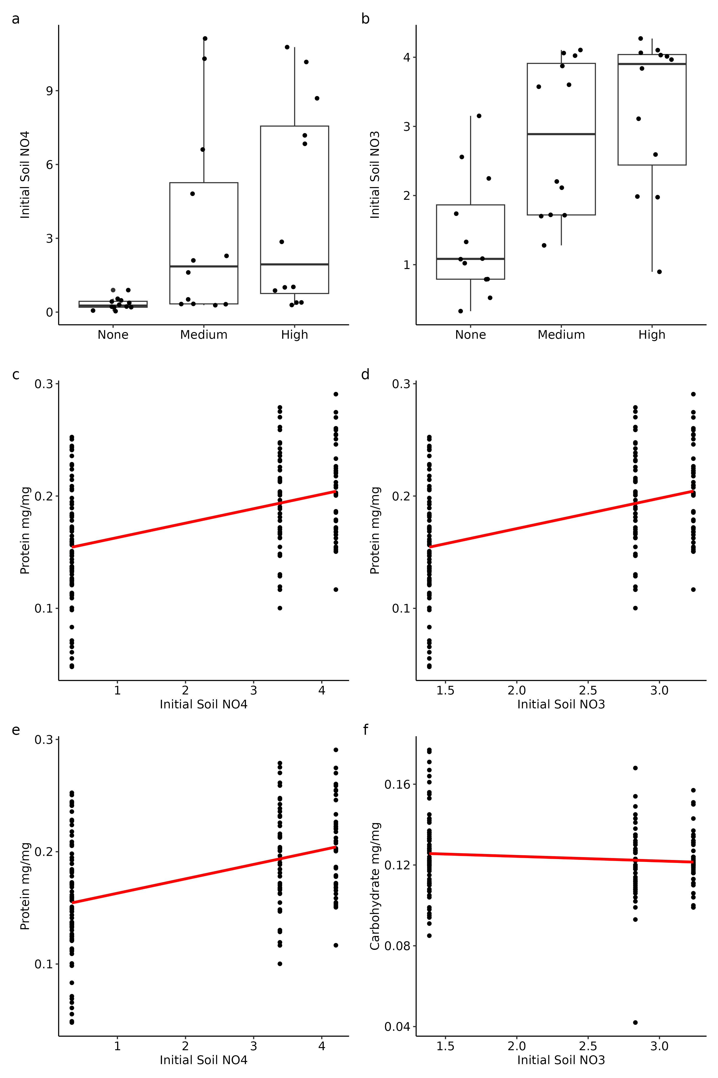
Supplementary Figure 1: Field cage soil nitrogen content by treatment (A & B) and regressed with plant carbohydrates and protein (C-F).

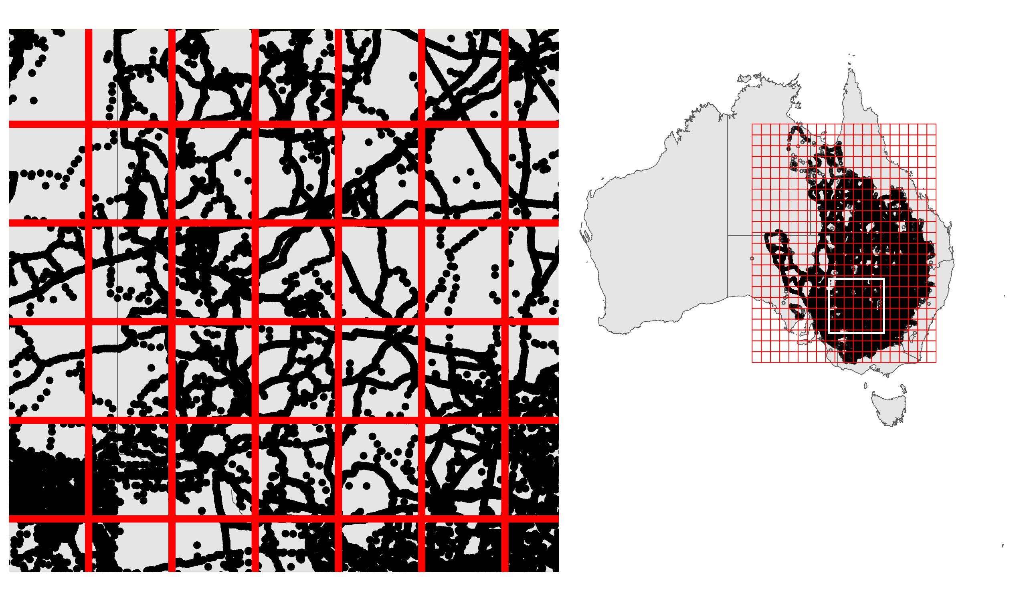
Supplementary Figure 2: Map illustrating the summarization of point observation data into a fishnet grid across eastern Australia. The inset map location is represented by the white box. We summed the number of outbreak, nil, and total observations. The grid in this figure is not at a 1 km² scale for demonstration purposes, as the cells would be too small to see.

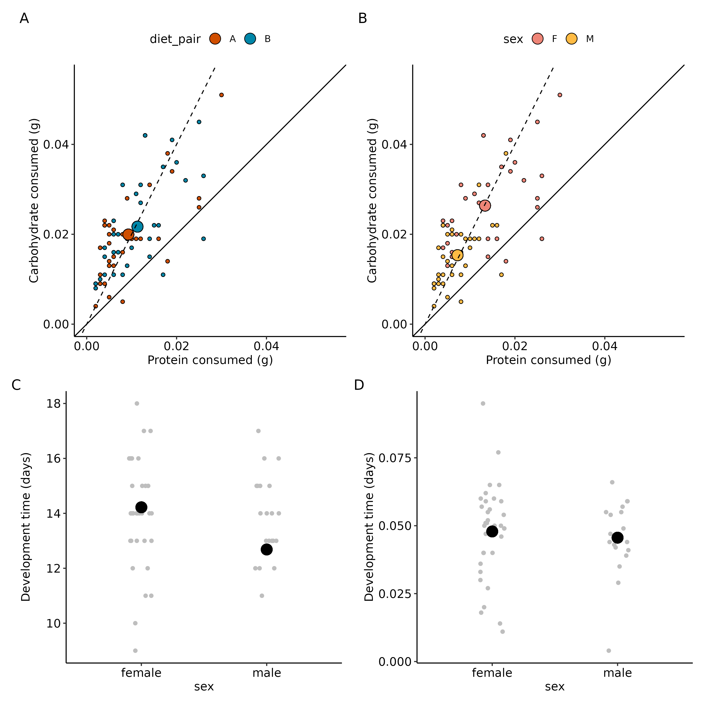
Supplementary Figure 3: Nutrient consumption for outbreaking field populations of C. terminifera by diet pair (A) and sex (B) and development time (C) specific growth rate (D) by sex. The P:C ratio did not differ between diet pairing and sex. Females consumed more diet (but kept the same ratio) than males. Big circles represent estimated marginal means from the model while little circles represent raw data.

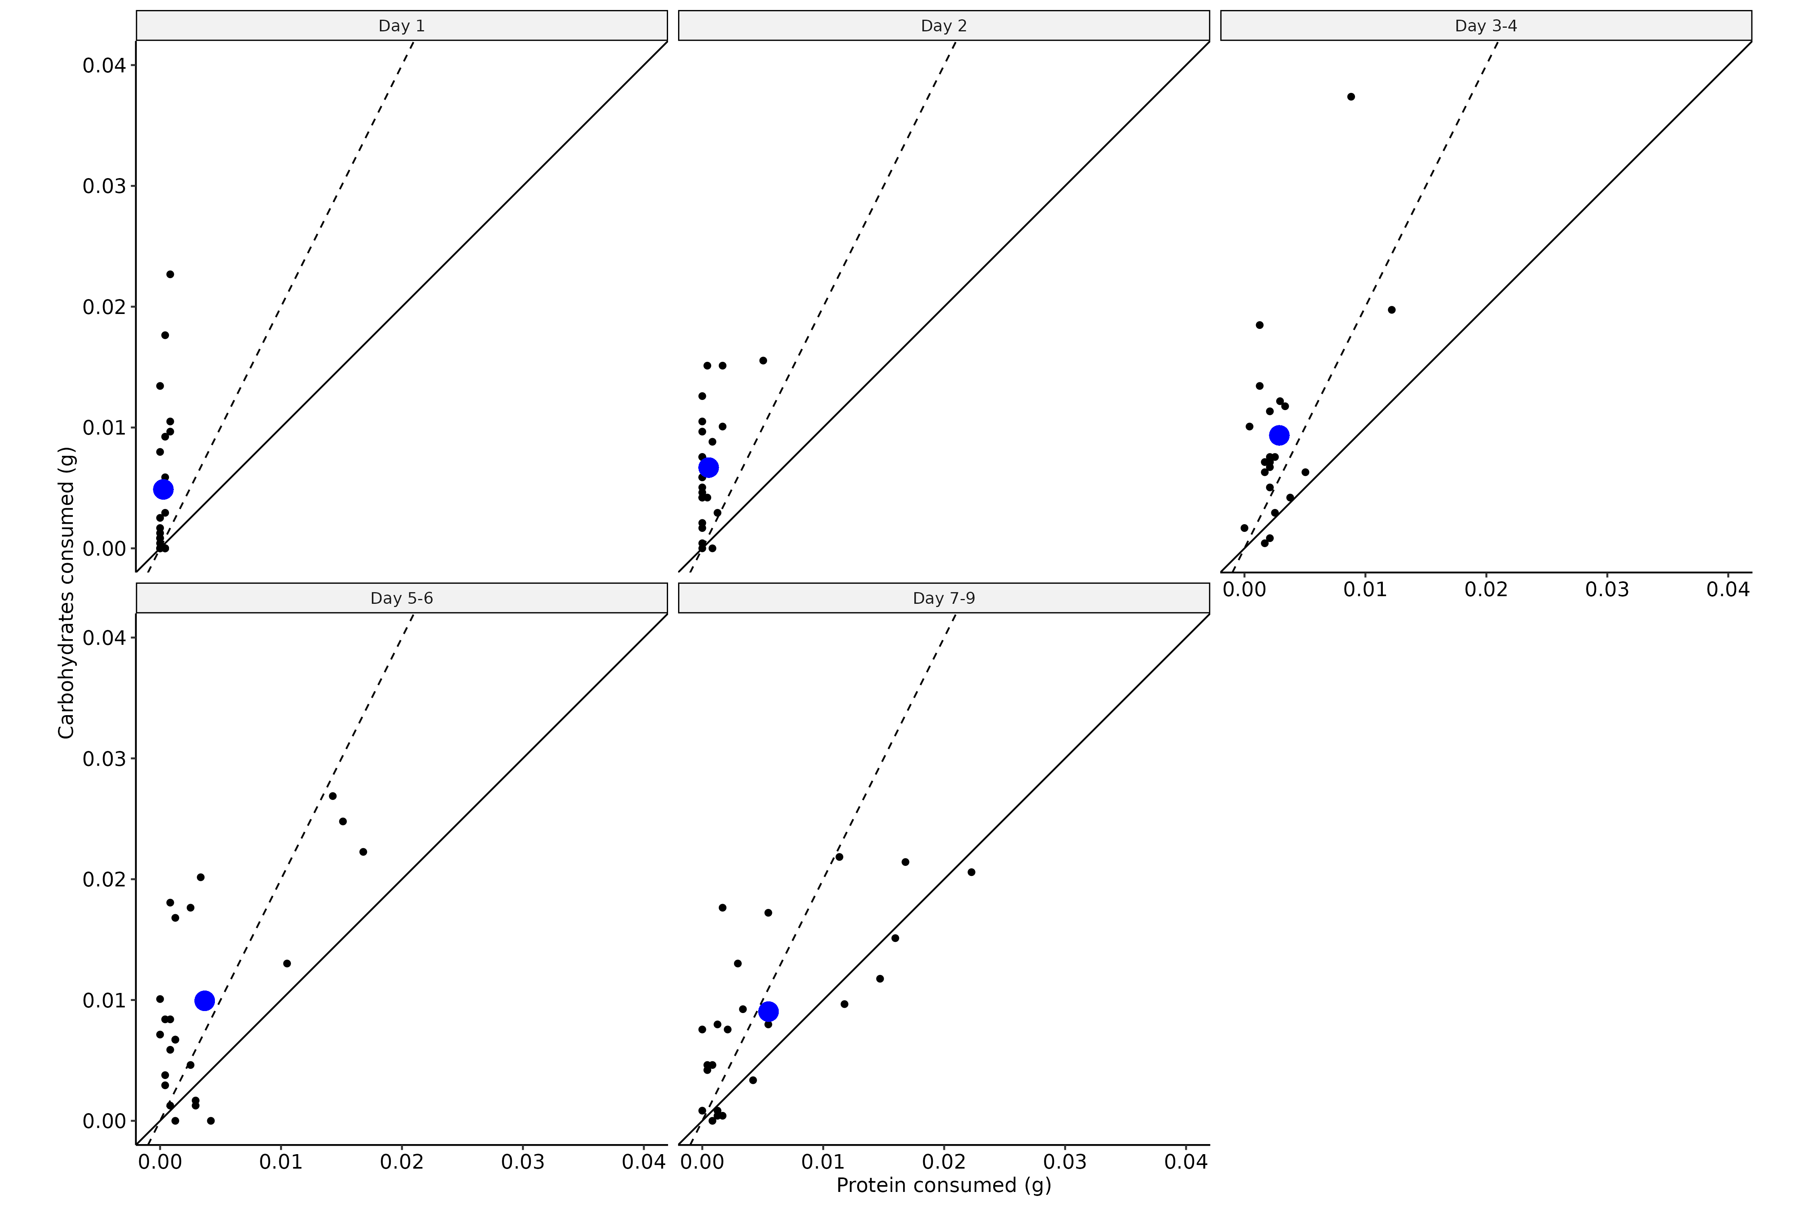
Supplementary Figure 4: Individual time step intake targets for grasshoppers kept in both high nitrogen fertilization and control cages. Blue dots represent estimated marginal means from the model while blacks dots represent raw individual intake targets.

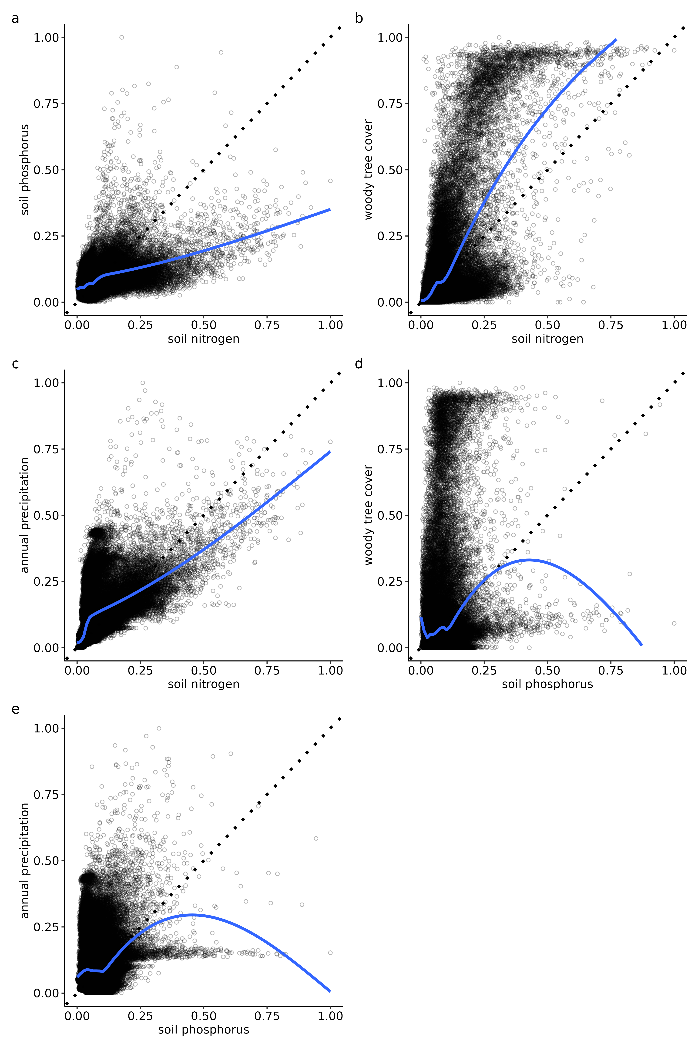
Supplementary Figure 5: Environmental variable correlations between mean annual precipitation, soil nitrogen, soil phosphorus, and woody vegetation pixel coverage. Mean annual precipitation was sourced from WorldClim V1 Bioclim, soil nitrogen and phosphorus was sourced from Soil and Landscape Grid of Australia, and woody vegetation pixel coverage was sourced from Global Forest Cover Change dataset. We averaged woody coverage for each pixel between the years 2000 and 2017. For all rasters, we randomly sampled 100,000 georeferenced points and extracted values. All values have been scaled and min-max normalized (to fall within 0-1) for visual clarity otherwise, unit scales would mask relationships. Dashed line represents a 1:1 slope and the blue line is a cubic spline with 10 knots.

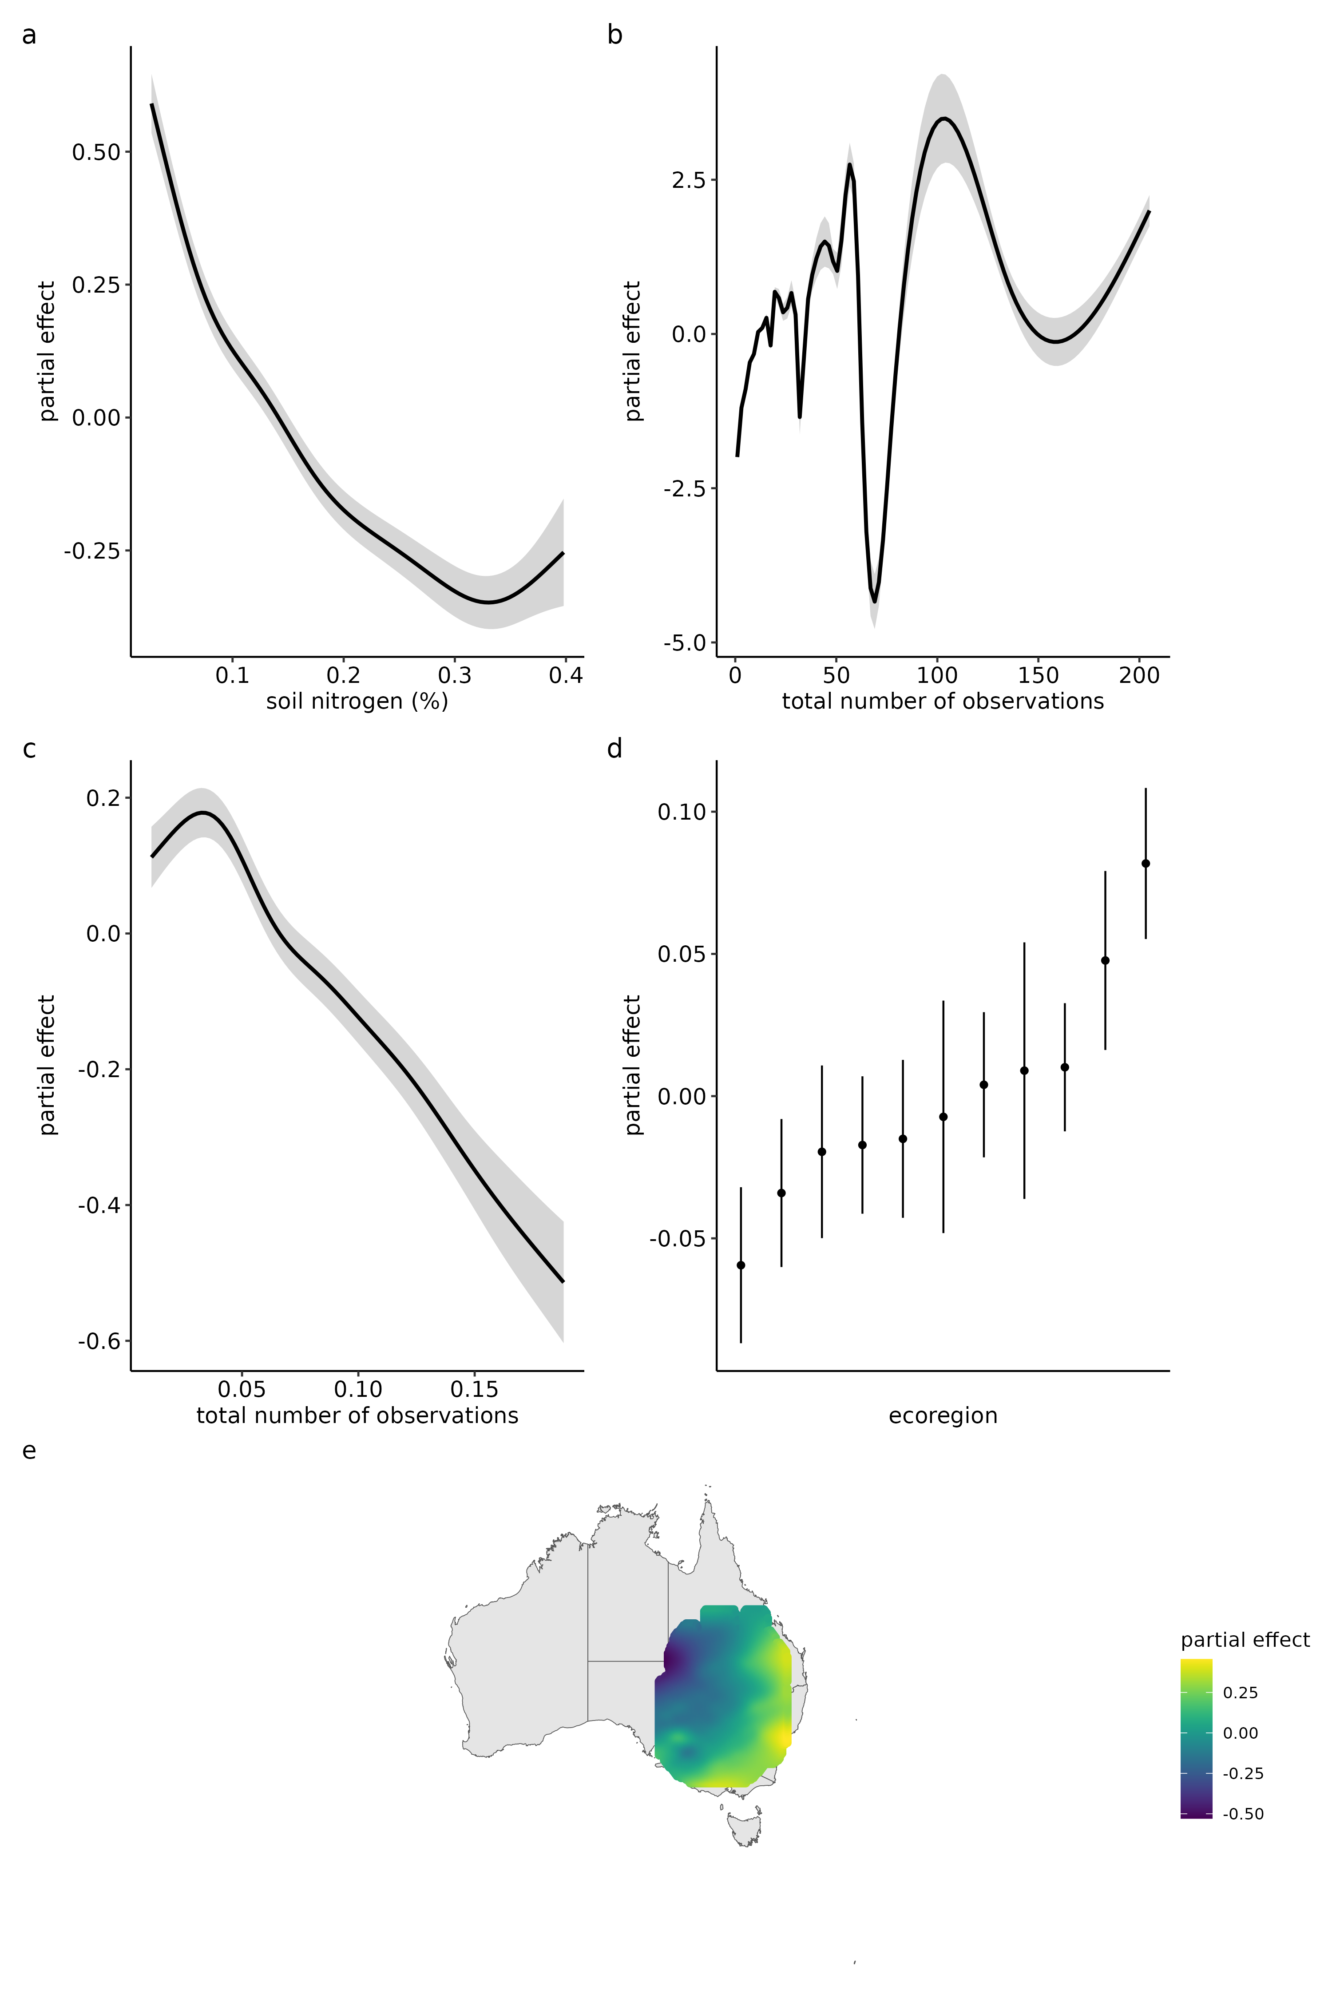
Supplementary Figure 6: Historical outbreaks record survey data modeling with soil nitrogen and phosphorus.

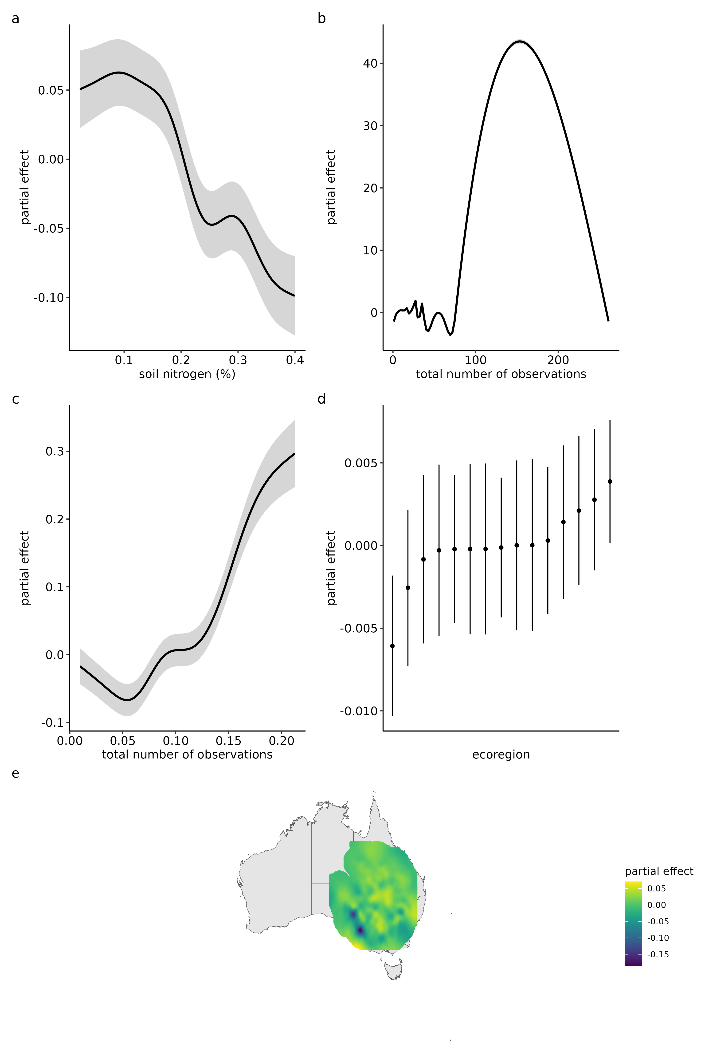
Supplementary Figure 7: Historical nil record survey data modeling with soil nitrogen and phosphorus.

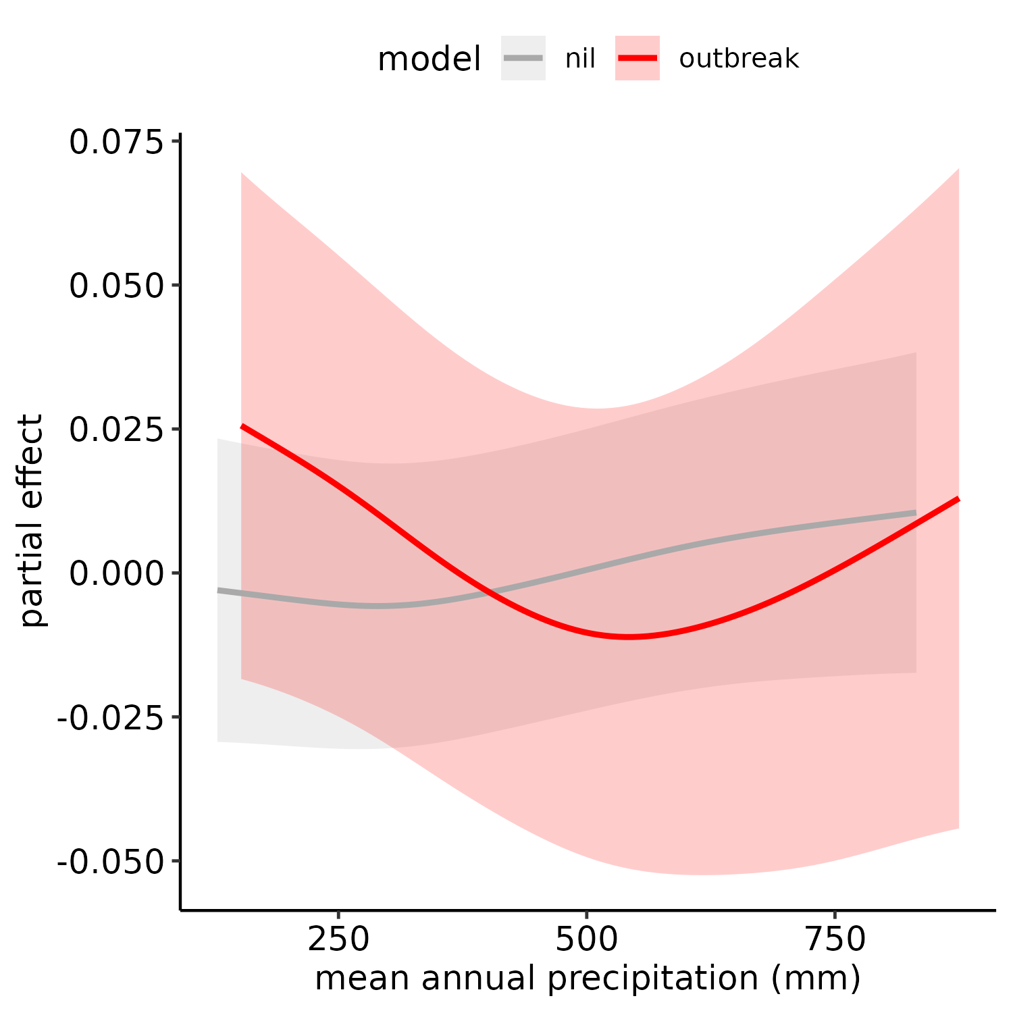
Supplementary Figure 8: The relationship between locust outbreaks and nil observations and mean annual precipitation. This is included as a visual comparison for the soil nitrogen relationship seen in Figure 5

treatment | species | date | Plant C mg/mg | Plant N | Plant P mg/mg | Plant Carb mg/mg | Soil NO3 mg/L | Soil NO4 mg/L
High | Digitaria spp. | 2015-12-01 | 0.419 | 0.027 | 0.182 | 0.108 | 3.238 | 4.207
 | Enteropogon spp. | 2015-11-11 | 0.425 | 0.030 | 0.199 | 0.128
 | Enteropogon spp. | 2015-11-25 | 0.414 | 0.028 | 0.180 | 0.120
 | Enteropogon spp. | 2015-12-01 | 0.414 | 0.024 | 0.163 | 0.125
 | Cyperus spp. | 2015-11-11 | 0.423 | 0.030 | 0.228 | 0.125
 | Cyperus spp. | 2015-11-25 | 0.415 | 0.032 | 0.220 | 0.131
 | Cyperus spp. | 2015-12-01 | 0.417 | 0.027 | 0.227 | 0.126
 | Plaspladium spp. | 2015-12-01 | 0.400 | 0.029 | 0.233 | 0.120
 | Rytidosperma spp. | 2015-11-11 | 0.424 | 0.023 | 0.206 | 0.125
 | Rytidosperma spp. | 2015-11-25 | 0.422 | 0.029 | 0.243 | 0.112
 | Rytidosperma spp. | 2015-12-01 | 0.419 | 0.025 | 0.217 | 0.117
Medium | Enteropogon spp. | 2015-11-11 | 0.431 | 0.042 | 0.209 | 0.126 | 2.831 | 3.385
 | Enteropogon spp. | 2015-11-25 | 0.417 | 0.026 | 0.210 | 0.137
 | Enteropogon spp. | 2015-12-01 | 0.415 | 0.022 | 0.146 | 0.124
 | Cyperus spp. | 2015-11-11 | 0.424 | 0.038 | 0.213 | 0.119
 | Cyperus spp. | 2015-11-25 | 0.420 | 0.029 | 0.239 | 0.127
 | Cyperus spp. | 2015-12-01 | 0.418 | 0.022 | 0.188 | 0.135
 | Plaspladium spp. | 2015-12-01 | 0.414 | 0.020 | 0.243 | 0.094
 | Rytidosperma spp. | 2015-11-11 | 0.422 | 0.037 | 0.227 | 0.106
 | Rytidosperma spp. | 2015-11-25 | 0.420 | 0.028 | 0.242 | 0.115
 | Rytidosperma spp. | 2015-12-01 | 0.422 | 0.021 | 0.181 | 0.116
None | Enteropogon spp. | 2015-11-11 | 0.432 | 0.031 | 0.164 | 0.145 | 1.387 | 0.331
 | Enteropogon spp. | 2015-11-25 | 0.414 | 0.021 | 0.194 | 0.115
 | Enteropogon spp. | 2015-12-01 | 0.405 | 0.023 | 0.114 | 0.130
 | Cyperus spp. | 2015-11-11 | 0.425 | 0.032 | 0.228 | 0.144
 | Cyperus spp. | 2015-11-25 | 0.417 | 0.027 | 0.232 | 0.137
 | Cyperus spp. | 2015-12-01 | 0.408 | 0.026 | 0.154 | 0.126
 | Plaspladium spp. | 2015-12-01 | 0.399 | 0.028 | 0.183 | 0.095
 | Austrostipa spp. | 2015-12-01 | 0.416 | 0.013 | 0.150 | 0.104
 | Rytidosperma spp. | 2015-11-11 | 0.420 | 0.026 | 0.190 | 0.124
 | Rytidosperma spp. | 2015-11-25 | 0.417 | 0.027 | 0.232 | 0.133
 | Rytidosperma spp. | 2015-12-01 | 0.418 | 0.022 | 0.142 | 0.121
 | unknown | 2015-12-01 | 0.413 | 0.031 | 0.168 | 0.101
Supplementary Table 1: Field plot nutrient content for plant species collected from within the treatment plots but outside of the locust cages for three time points during the experiment. Soil nitrogen is also shown per each treatment. Trt = Treatment, C = carbon, N = Nitrogen, P = protein, Carb = Carbohydrates.

plant | None | Medium | High
plant cover | 35.5% | 35.2% | 27.4%
Urochloa panicoides | 13.3% | 15.0% | 47.5%
Enteropogon acicularis | 60.1% | 65.5% | 67.4%
Austrodanthonia caespitosa | 15.4% | 18.3% | 15.2%
Cyperus rotundus | 19.3% | 17.3% | 15.0%
stipa species | 0.0% | 5.0% | 0.0%
Supplementary Table 2: Averaged plant ground cover (%) across all cages per treatment. Ground cover was estimated on November 11th, 2015.

model | deltaBIC | deltaAIC | deltaAICc
macronutrient ~ population + diet_pair + sex + s(initial_mass_g, k=30) | 0.01 | 0.00 | 0.01
macronutrient ~ population + diet_pair + sex + initial_mass_g | 7.28 | 2.81 | 4.80
macronutrient ~ population + diet_pair + sex | 0.00 | 0.00 | 0.00
macronutrient ~ 1 | 2.56 | 15.96 | 12.28
Supplementary Table 3: Model selection criteria via Akaike information criterion (AIC), AIC corrected for small sample size (AICc), and bayesian information criterion. Model formula with the dependent variable on the left side and independent variables on the right side of the equation. For all criteria, the lower the number, more negative in this case, the better fit model.

 | Development Time |  |  | Specific Growth Rate
comparisons | estimate | SE | adjusted p-value | estimate | SE | adjusted p-value
14p:28c - 21p:21c | -0.917 | 0.624 | 0.465 | 0.011 | 0.005 | 0.164
14p:28c - 35p:7c | -1.709 | 0.664 | 0.062 | 0.010 | 0.006 | 0.322
14p:28c - 7p:35c | -2.716 | 0.603 | 0.000 | 0.026 | 0.005 | 0.000
21p:21c - 35p:7c | -0.792 | 0.609 | 0.567 | -0.001 | 0.005 | 0.997
21p:21c - 7p:35c | -1.799 | 0.571 | 0.014 | 0.015 | 0.005 | 0.020
35p:7c - 7p:35c | -1.007 | 0.619 | 0.374 | 0.016 | 0.005 | 0.029
Supplementary Table 4: Posthoc comparisons for diet treatments for C. terminifera individual specific growth rate and development time. SE = standard error

